**Introduction**

This document provides some reference codes using general SQL syntax for data queries and creation of databases and tables. The codes provided in this document are written in PostgreSQL, with pgAdmin being the graphical user interface for performing queries and connecting to PostgreSQL databases. The skills relevant to PostgreSQL are also applicable to any other major SQL database, such as MySQL, Microsoft SQL Server, Amazon Redshift, Oracle and much more. The sample databases used for this document are ‘dvdrental’ (database of a dvd rental shop) and ‘exercises’ (database of a facilities management site).

The following are the topics presented in this document:

1. SQL Statements
2. GROUP BY Statements
3. Joins
4. Advanced SQL commands
5. Creating Databases and Tables
6. Conditional Expressions and Operators
7. PostgreSQL with Python

**SQL Statements:**

* **SELECT**
  + One of the most commonly used statement.
  + Can be used to retrieve information from a table.
  + Syntax:



* + Example query:

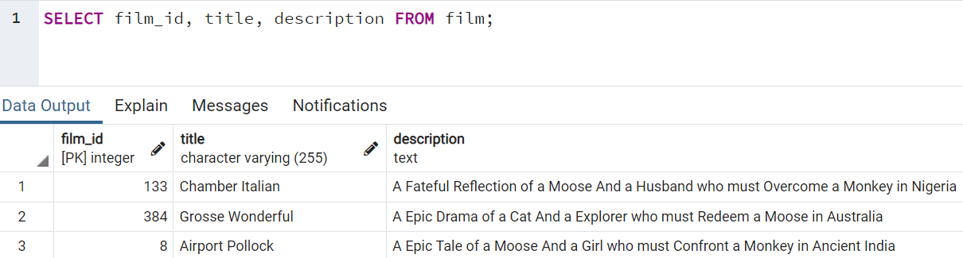

* **SELECT DISTINCT**
  + Can be used to return only distinct values of a column.
  + Syntax:



* + Example query:

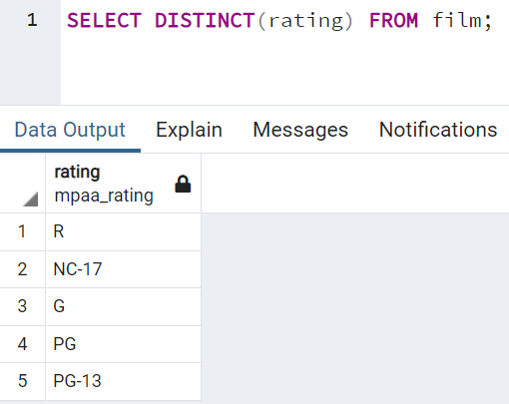

* **COUNT**
  + Return the number of input rows that match specific conditions of a query.
  + Syntax:



* + Good to combine with DISTINCT for returning the number of distinct values of a column:



* + Example query:

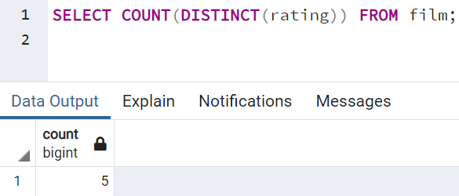

* **SELECT WHERE**
  + For us to specify conditions on columns for the rows to be returned.
  + Syntax:

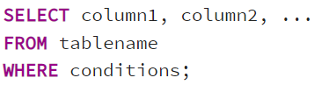

* + Comparison Operators:

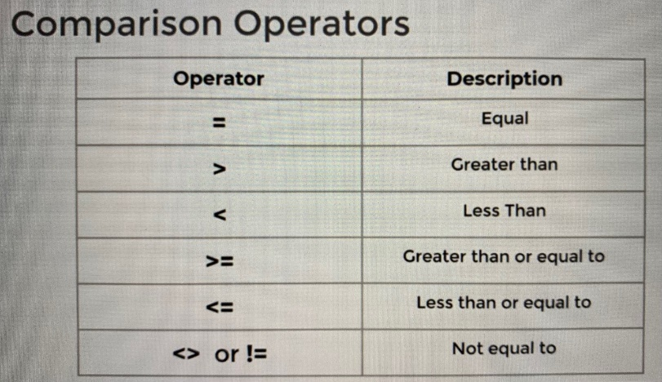

* + Logical operators (for combining multiple comparison operators): AND, OR, NOT.
  + Example query:

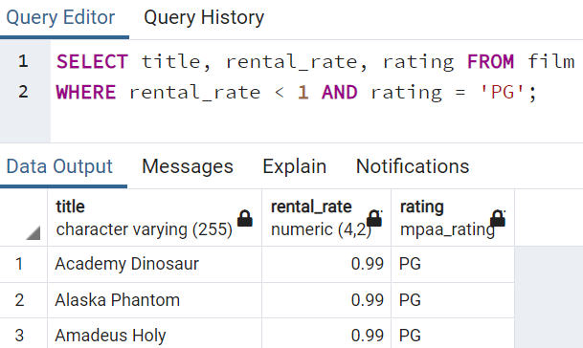

* **ORDER BY**
  + For sorting rows based on column value (ascending or descending).
  + Sorting is done after selection or filtering.
  + Syntax:

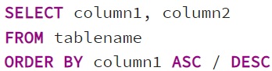

Note: ASC (ascending) by default.

* + Example query:

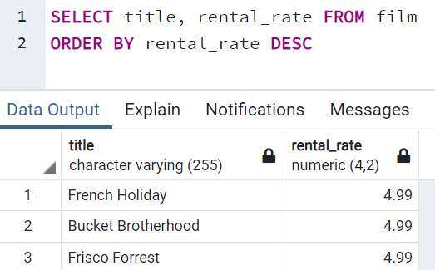

* + Can also apply ORDER BY on multiple columns:

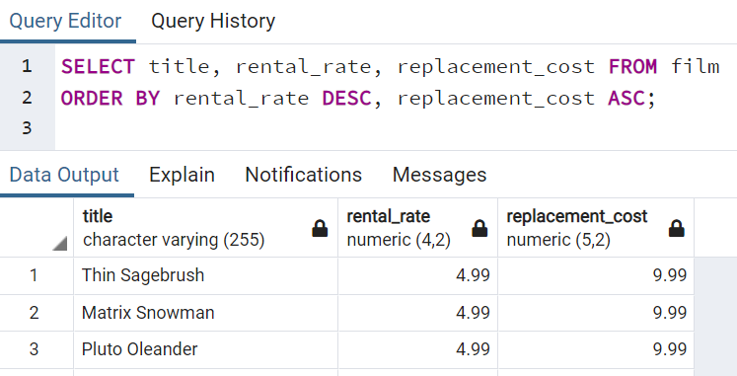

* **LIMIT**
  + Can be used to limit number of rows returned from a query.
  + Syntax:

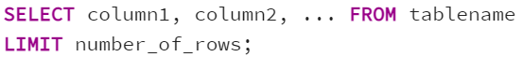

* + Example query:

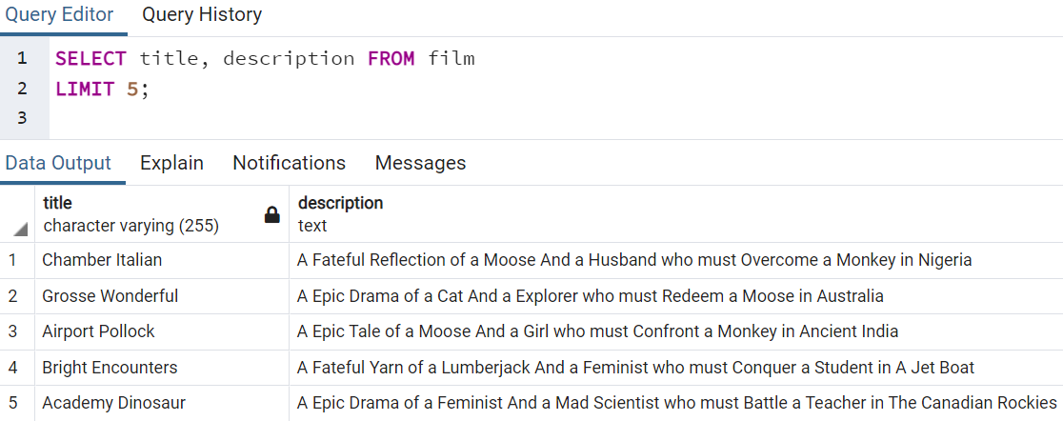

* **BETWEEN**
  + Can be used together with WHERE to return rows with specified range of column values.
  + Syntax:

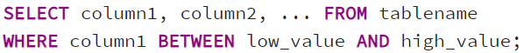

Note: Both upper and lower limits are included.

* + Can also be used with NOT (NOT BETWEEN):



Note: Both upper and lower limits are not included.

* + Example query:

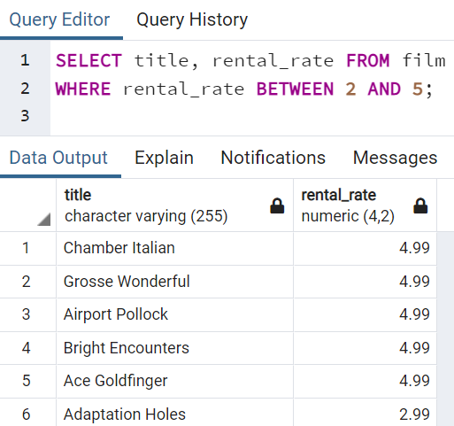

* + Can also be used with date data. Example query:

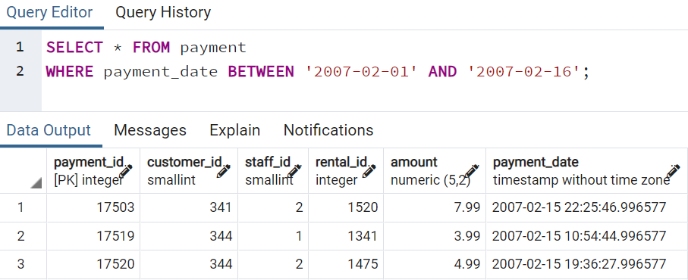

Note: The query above is for retrieving all payments made from ‘2007-02-01’ to ‘2007-02-15’. The end date for the query above is ‘2007-02-16’ since the start time for a day is at 0:00 and all the payments made up to just before 2007-02-16 0:00 shall be captured for the specified range of dates. If ‘2007-02-15’ is used instead for the query, then all those payments made on ‘2002-02-15’ will not be captured.

* **IN**
  + Can be used together with WHERE to return rows with specified column values.
  + Syntax:

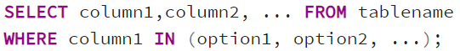

* + Can also be used with NOT (NOT IN):
  + Example query:

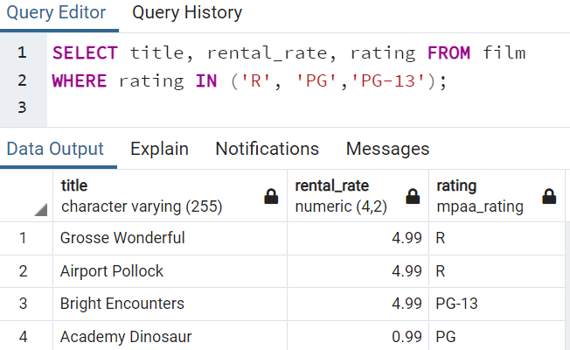

* **LIKE AND ILIKE**
  + Can be used to perform pattern matching (regular expression) against string data with the use of wildcard characters:
    - %: Matches any sequence of characters.
    - _: Matches any single character (multiple underscores allowed).
  + Can be used with NOT (eg. NOT LIKE).
  + LIKE => case-sensitive; ILIKE => case-insensitive
  + Example query:

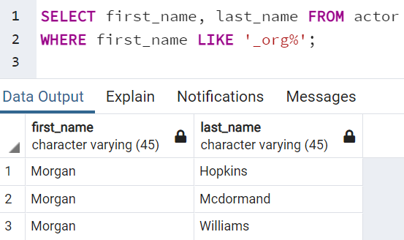

* **Some examples for common business queries:**
  + How many payment transactions were greater than $5.00?

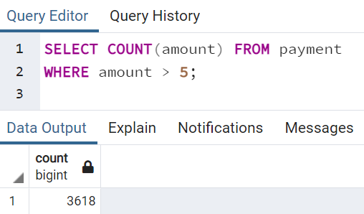

* + How many actors have a first name that starts with the letter P?

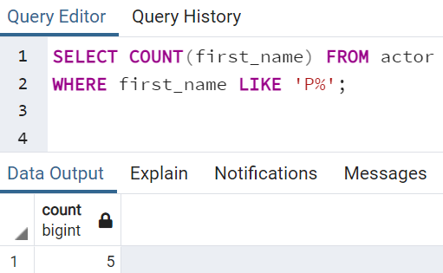

* + How many unique districts are our customers from?

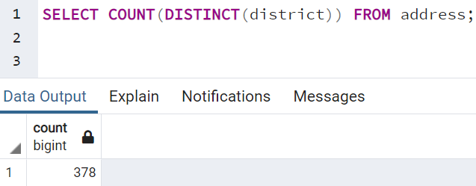

* + How many films have a rating of R and a replacement cost between $5 and $15?

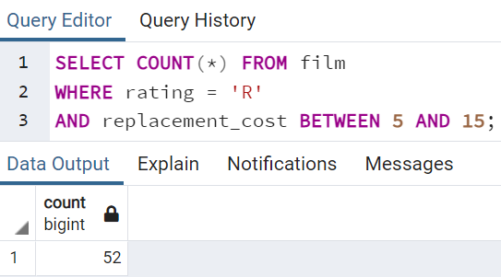

* + How many films have the word ‘Truman’ somewhere in the title?

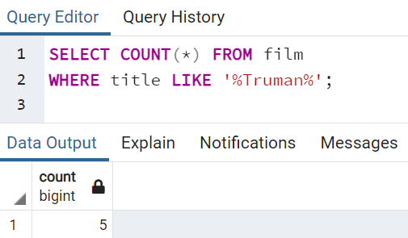

**GROUP BY Statements:**

* **Aggregate functions:**
  + The main idea behind an aggregate function is to take multiple inputs and return a single output (eg. take in 100 numbers and return their average value).
* **Some commonly used aggregate functions:**
  + AVG(): Return the average value of a column.
  + COUNT(): Return the row numbers (as per specified conditions if applicable).
  + MAX(): Return the max value of a column.
  + MIN(): Return the min value of a column.
  + SUM(): Return the sum of a column.

MIN() and MAX() can be used with dates also (MAX gives the latest, MIN gives the earliest).

Aggregate function calls happen only in the SELECT or HAVING clause.

* **GROUP BY**
  + Allow us to aggregate columns as per some category (another categorical column).
  + Syntax:

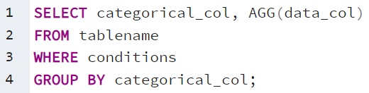

GROUP BY clause must appear right after a FROM or WHERE statement.

AGG() is one of the aggregate functions.

In the SELECT statement, columns must either have an aggregate function or be in the GROUP BY call.

* + Example query:

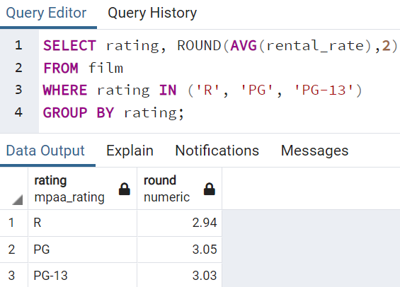

* **HAVING**
  + For us to filter after an aggregation has already taken place (WHERE statement cannot be used for the filtering since the aggregation will only take place at the GROUP BY call, which is after the WHERE statement).
  + Syntax:

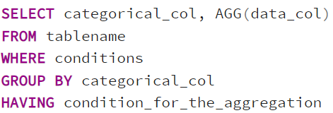

* + Example query:

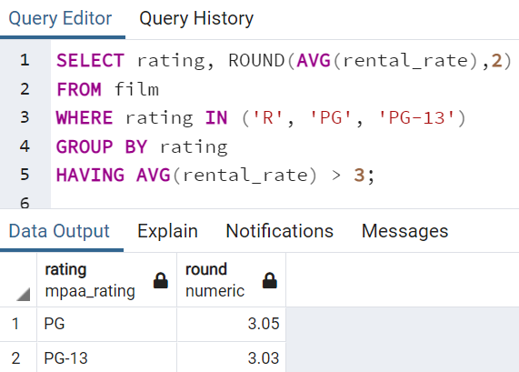

* **Some examples for common business queries:**
  + Which employee handled the most payments? (Most in terms of payments processed not total dollar amount)

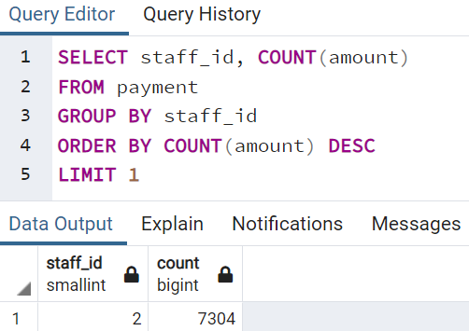

* + What is the average replacement cost per MPAA rating?

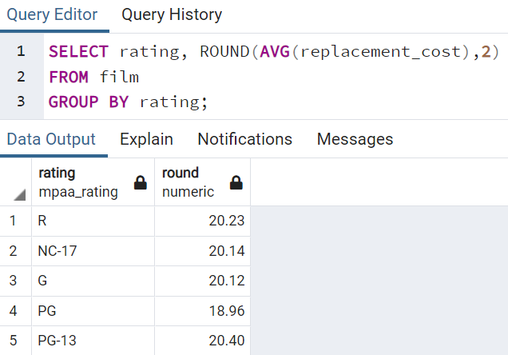

* + What are the customer ids of the top 5 customers by total spend?

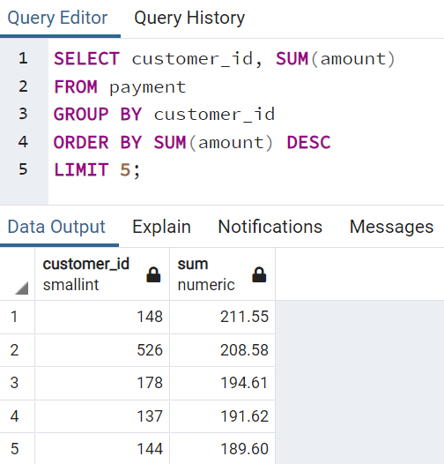

* + We are launching a platinum service for our most loyal customers. We will assign platinum status to customers that have had 40 or more transaction payments. What customer_ids are eligible for platinum status?

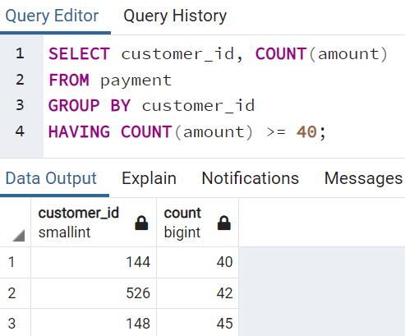

* + What are the customer ids of customers who have spent more than $100 in payment transactions with our staff_id member 2?

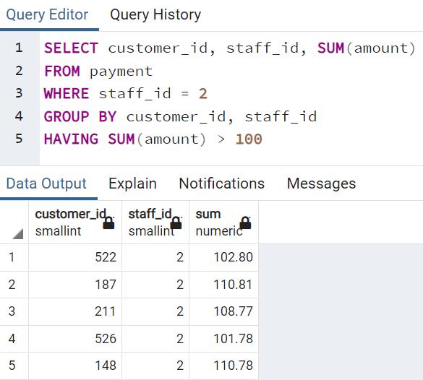

* + Return the customer ids of customers who have spent at least $110 with the staff member who has an id of 2.

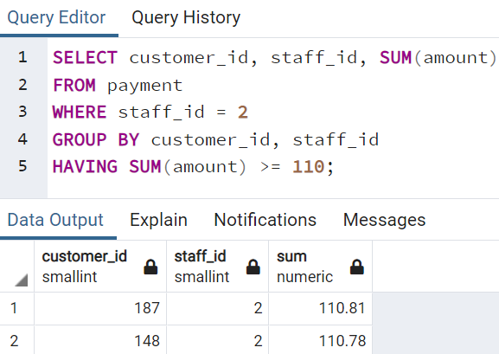

**Joins:**

* **Can be used to combine information from multiple tables.**
* **Different join types are selected based on how to deal with information only present in one of the joined tables.**
* **AS statement:**
  + Can be used for creating alias (new name) for clarifying the purpose of the output column.
  + AS operator will only be executed at the very end of a query, meaning alias cannot be used inside a WHERE operator.
  + Syntax:

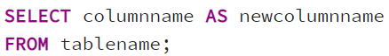

Example:

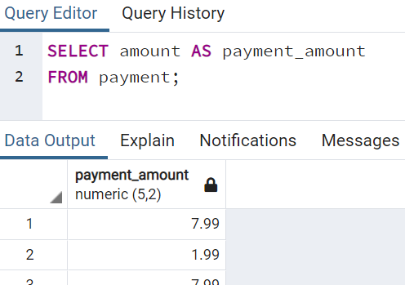

Can also be used with aggregate functions:

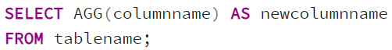

Example:

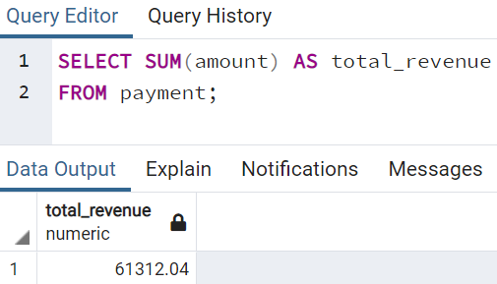

* **Different kinds of Joins:**
  + Inner Joins
    - Produce only the set of records that match in both Table A and Table B.
    - Syntax:

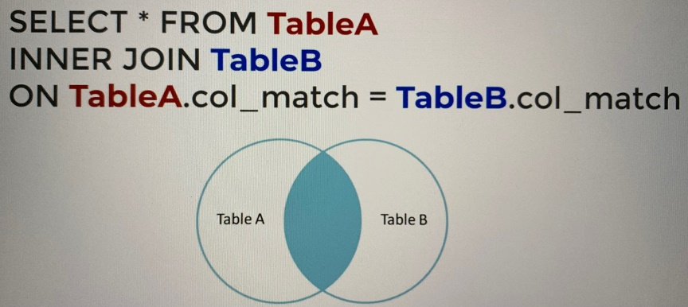

Note: Table order is not important for the case of inner join since the join is symmetrical.

* + - Example:

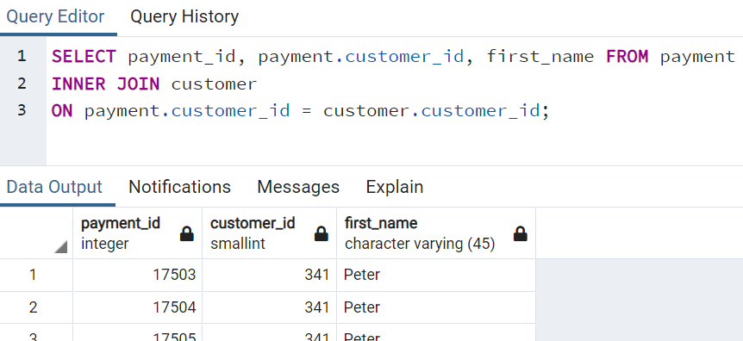

Note: To specify which table to refer (payment for this example) if the column can be found in both tables.

* + Full Outer Joins
    - Produce the set of all records in Table A and Table B, with matching records from both sides where available. If there is no match, the missing side will contain null.
    - Syntax:

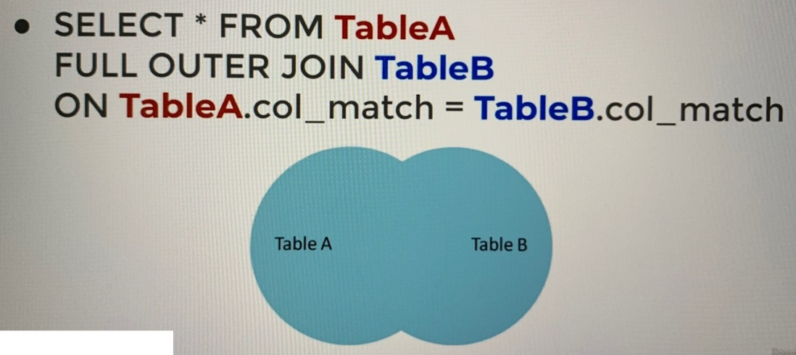

Note: Table order is not important for the case of full outer join since the join is symmetrical.

* + - Example:

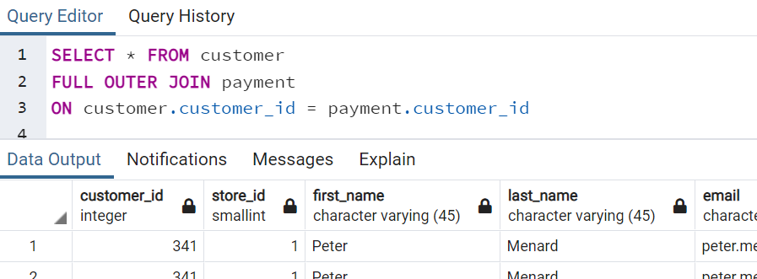

* + Full Outer Joins with WHERE statement
    - Get rows unique to either table (rows not found in both table and available in one of the tables only).
    - Exact opposite of an inner join.
    - Syntax:

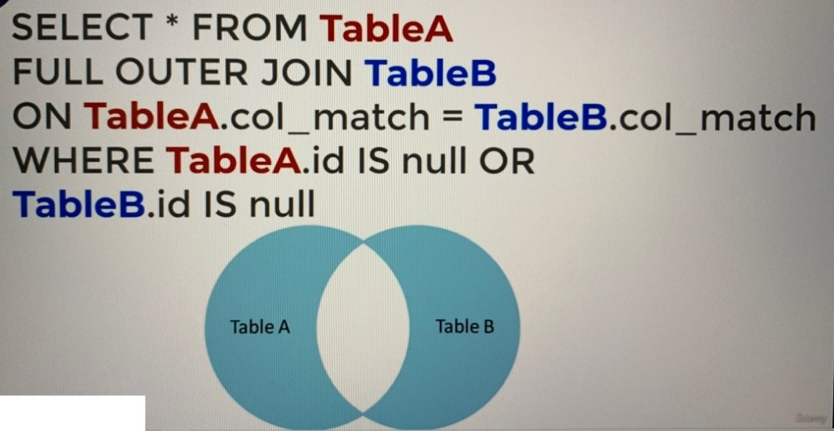

* + - Example:

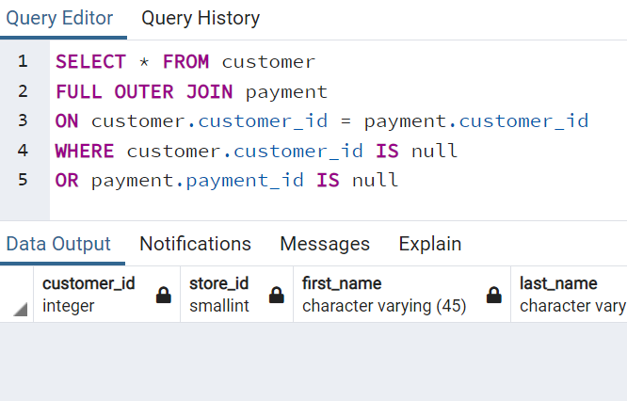

Note: In the query above we check for customer id which is unique to either customer or payment table and there is no row returned. This means that every customer id in the customer table has payment record in the payment table.

* + Left Outer Joins
    - Result in the set of records that are in the left table, if there is no match with the right table, the results are null.
    - Syntax:

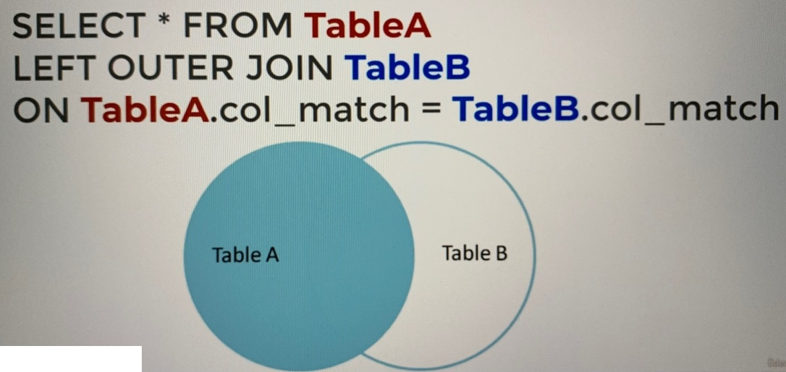

Note: Table order is important for the case of left outer join since the join is not symmetrical. Swapping Table A and Table B in the syntax will produce different results.

* + - Example:

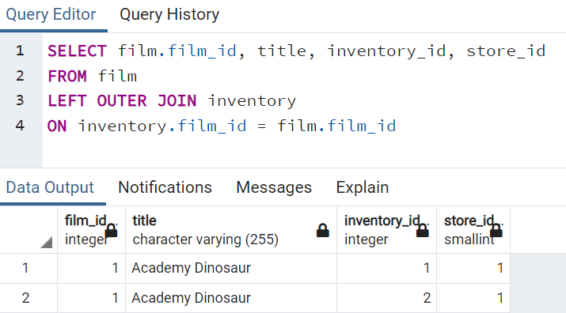

* + Left Outer Joins with WHERE statement
    - Get rows unique to the left table.
    - Syntax:

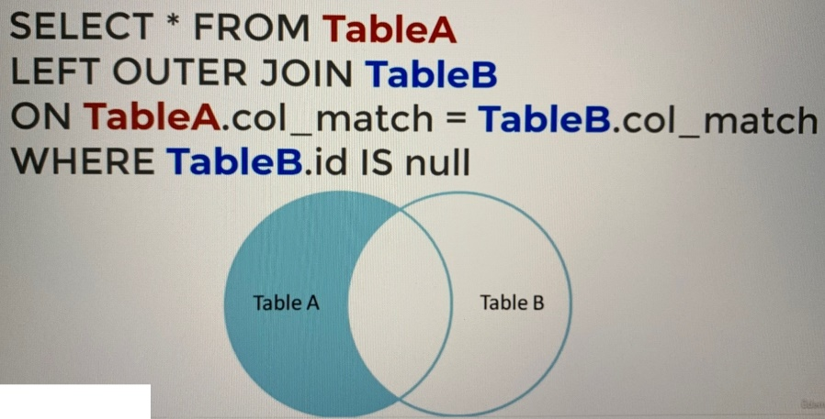

* + - Example:

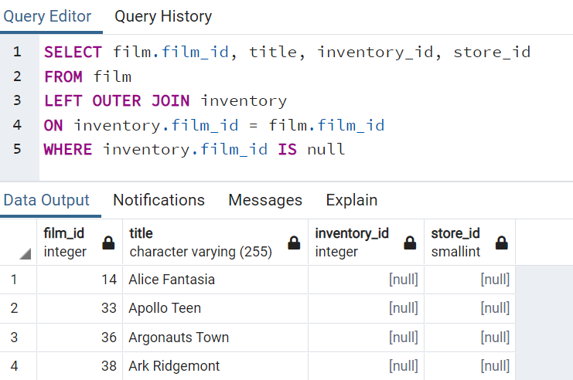

Notes: The result above shows those movie titles unique to film table, and none of them is found in the inventory table. This means that there is no inventory for all the movies in the result above.

* + Right Outer Joins
    - Essentially same as Left Outer Joins, except the tables are switched.
    - Syntax:

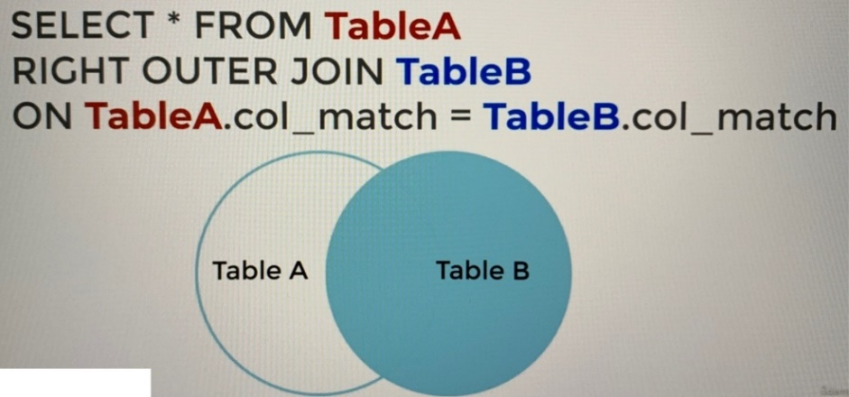

Note: Table order is important for the case of right outer join since the join is not symmetrical. Swapping Table A and Table B in the syntax will produce different results.

* + Right Outer Joins with WHERE statement
    - Get rows unique to the right table.
    - Syntax:

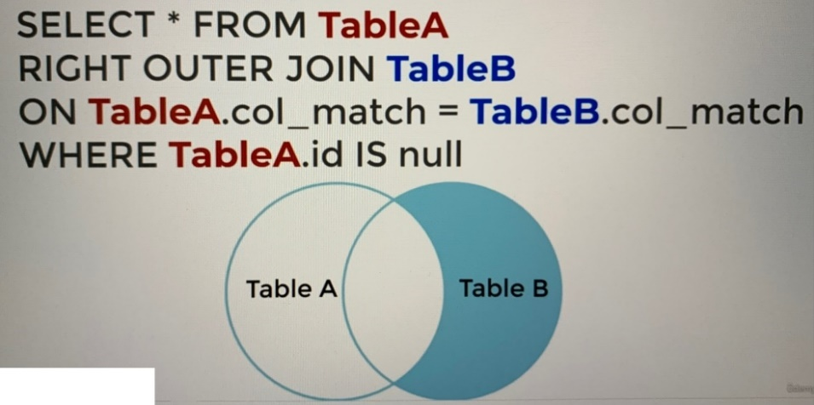

* + Union
    - Can be used to combine the result set of two or more SELECT statements.
    - Serve to directly concatenate two results together, essentially “pasting” them together.
    - Syntax:

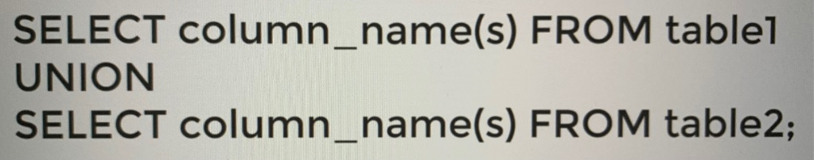

Example:

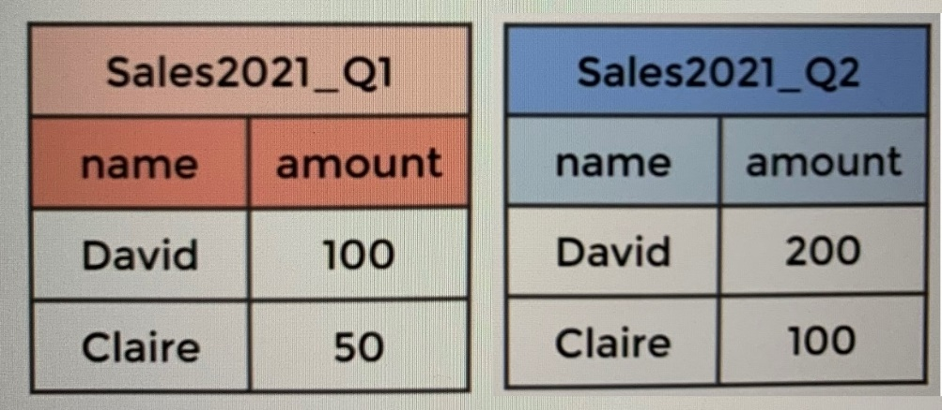

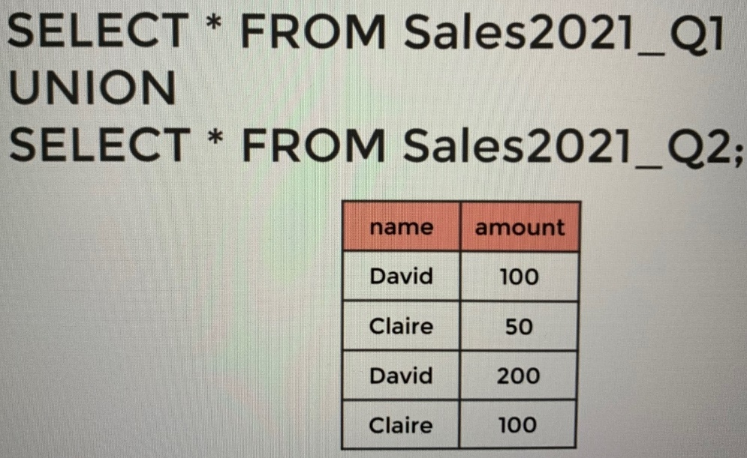

* **Some examples for common business queries:**
  + California sales tax laws have changed, and we need to alert our customers to this through email. What are the emails of the customers who live in California?

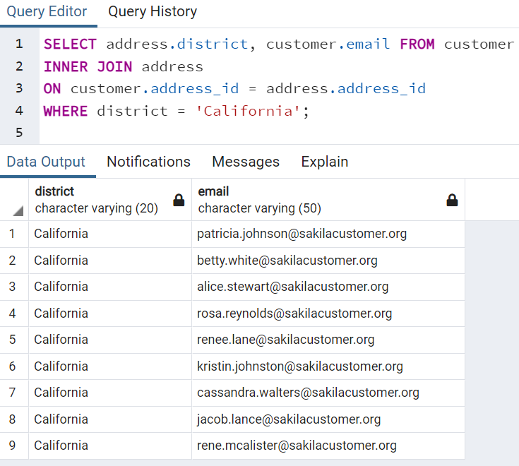

* + A customer walks in and is a huge fan of the actor “Nick Wahlberg” and wants to know which movies he is in. Get a list of all the movies “Nick Wahlberg” has been in.

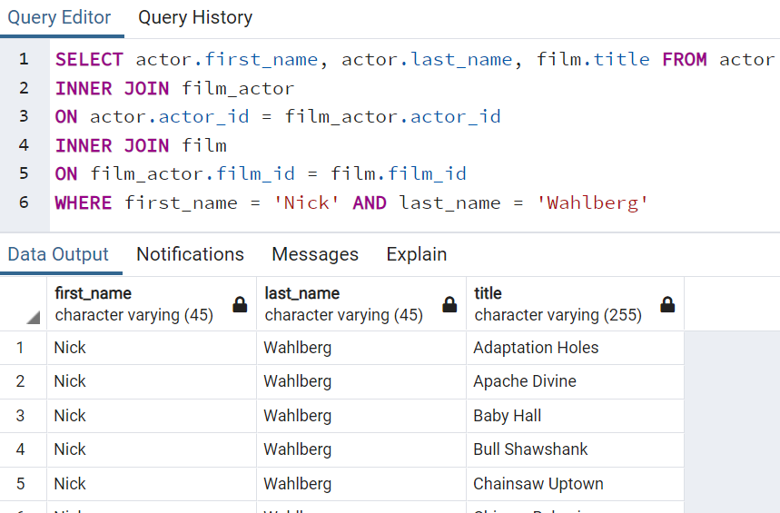

* **Summary for Joins:**



**Advanced SQL commands:**

* **Extracting information from a time-based data type using:**
  + EXTRACT()
    - Allow us to “extract” or obtain a sub-component of a date value:
      * YEAR
      * MONTH
      * DAY
      * WEEK
      * QUARTER
      * DOW
    - Syntax: EXTRACT(YEAR FROM date_col)
    - Example:

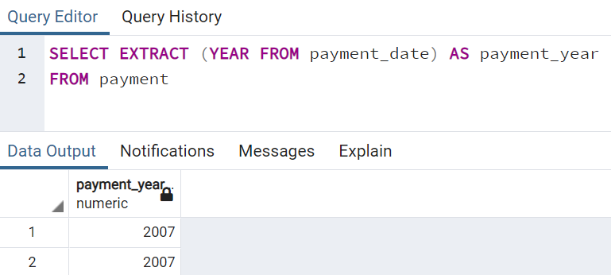

Notes: Alias is used for the extract result for clarity.

* + AGE()
    - Calculate and return the current age given a timestamp.
    - Syntax: AGE(date_col)
    - Example:

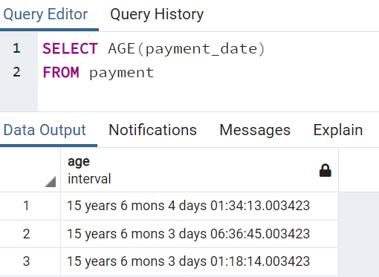

* + TO_CHAR()
    - General function to convert data types to text.
    - Useful for timestamp formatting (refer [PostgreSQL documentation](https://www.postgresql.org/docs/14/functions-formatting.html) for template patterns for Date/Time Formatting).
    - Example syntax: TO_CHAR(date_col, ‘mm-dd-yyyy’)
    - Example:

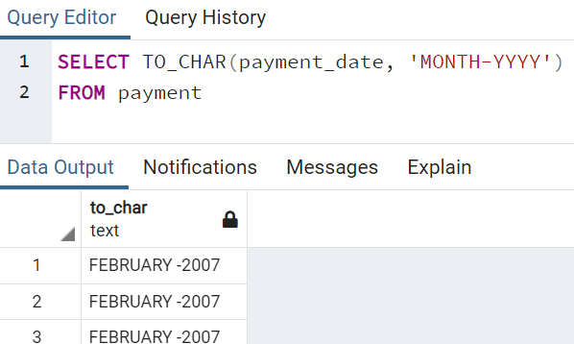

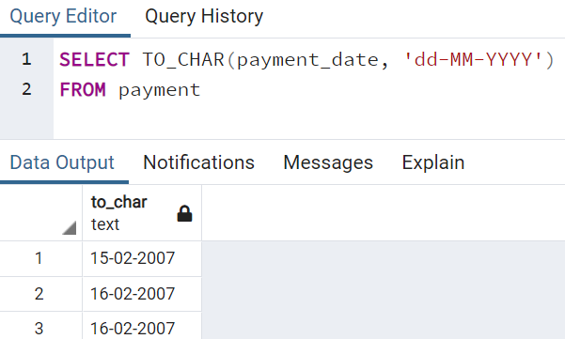

* **Math Functions**
  + For mathematical operations (refer [PostgreSQL documentation](https://www.postgresql.org/docs/14/functions-math.html) for available mathematical operations).
  + Syntax:

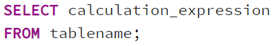

* + Example:

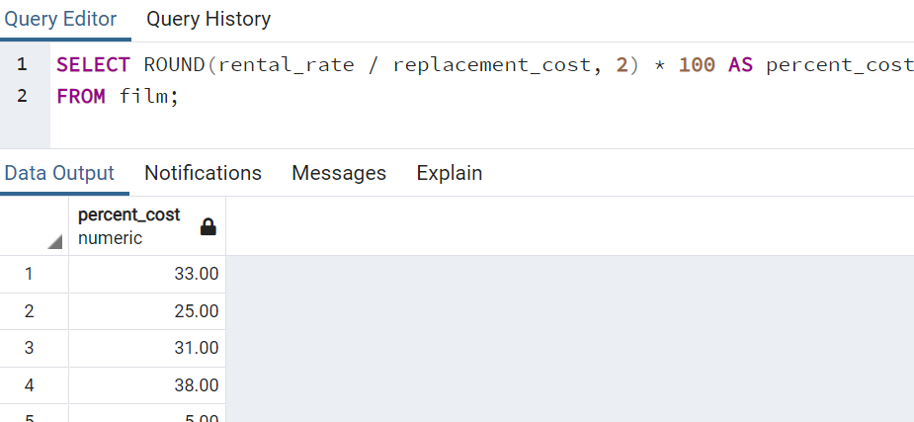

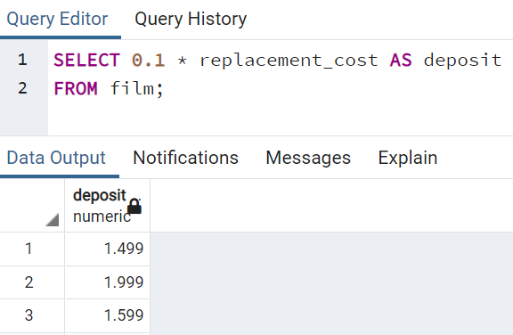

* **String Functions**
  + For editing, combining, and altering text data columns (refer [PostgreSQL documentation](https://www.postgresql.org/docs/14/functions-string.html) for available string operations).
  + Syntax:

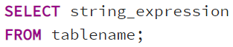

* + Example:

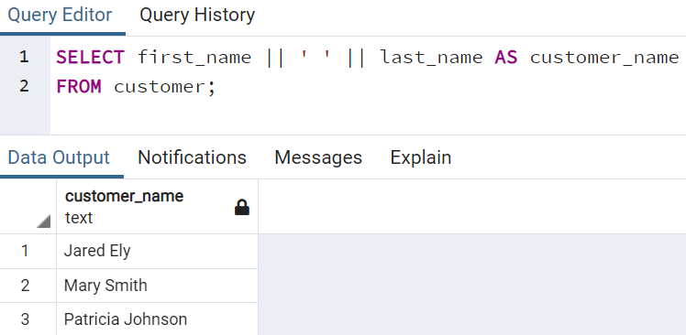

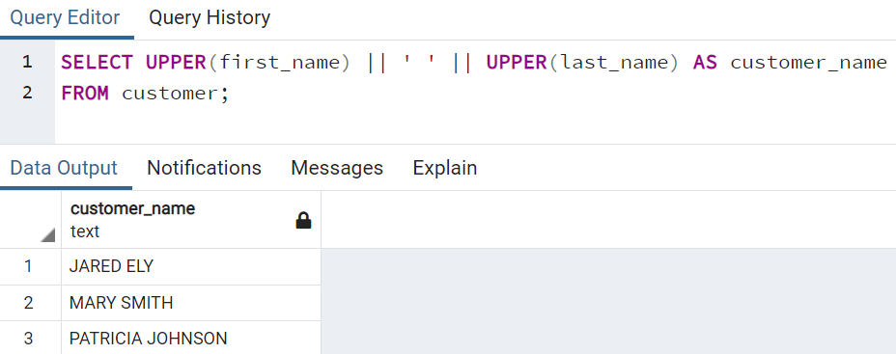

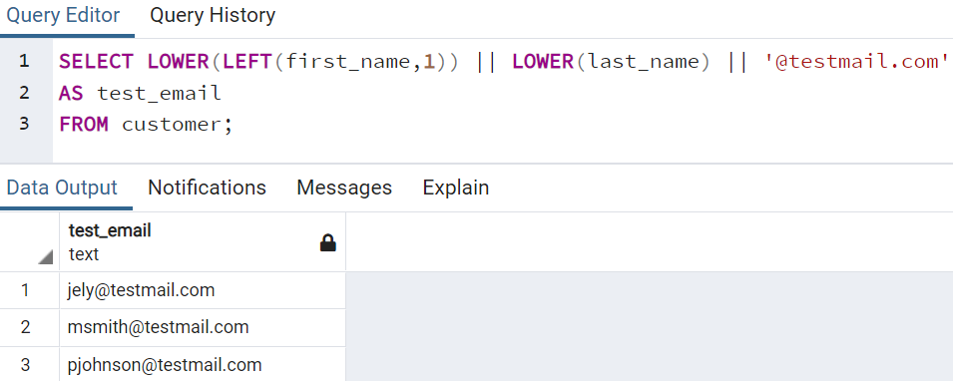

* **Sub-query**
  + Allow us to construct complex queries, essentially performing a query on the results of another query.
  + The syntax is straightforward and involves two SELECT statements.
  + Example syntax:

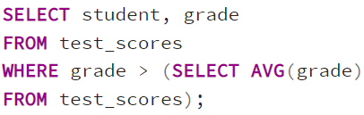

Note: Code inside the sub-query (SELECT AVG(grade) FROM test_scores) will get executed first.

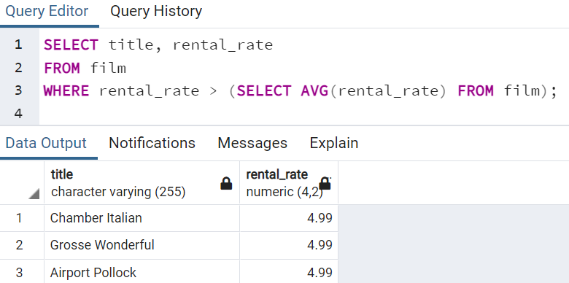

We can also use the IN operator in conjunction with a sub-query to check against multiple results returned.

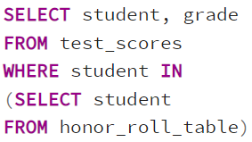

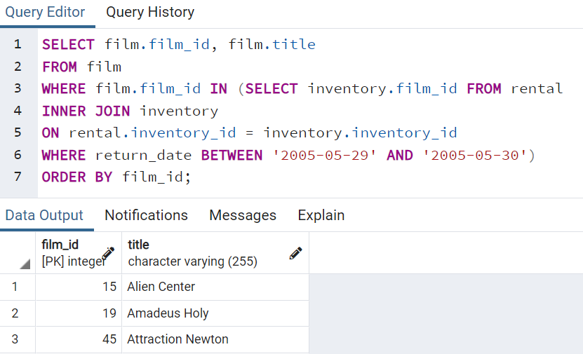

Codes above return the ids and titles of those films returned on 2005-05-29.

* + EXISTS operator is used to test for existence of rows in a sub-query.
  + Typical syntax for EXISTS operator with sub-query:

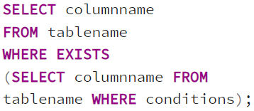

* + Example:

Return the list of customer names who have at least one payment whose amount is greater than $11.

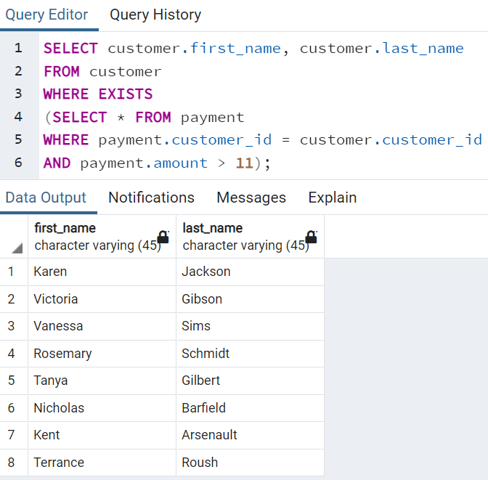

* **Self-Join**
  + A self-join is a query in which a table is joined to itself (can be viewed as a join of two copies of the same table).
  + Self-joins are useful for comparing values in a column of rows within the same table.
  + Essential to use aliases, otherwise the table names would be ambiguous.
  + Syntax:

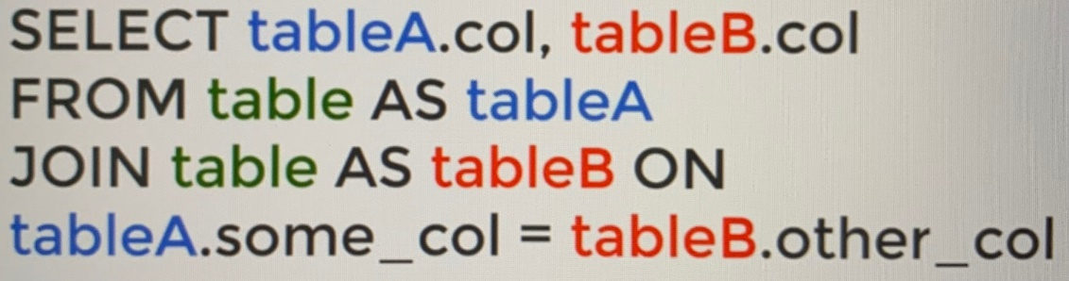

Note: All the tables above are referring to the same table.

* + Example:

Return a table which contains all the pairs of films that have the same length:

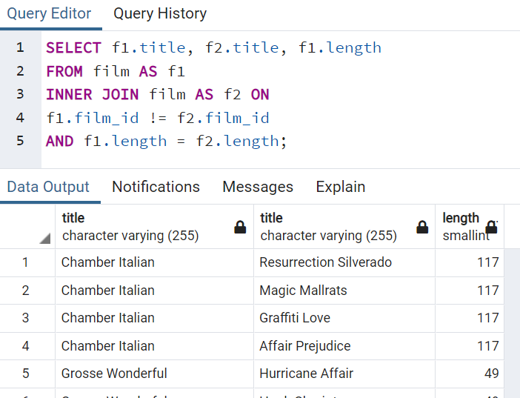

* **Some examples for common business queries (using dvdrental database):**
  + During which months did payments occur? Return the full month names all in CAPITAL LETTERS.

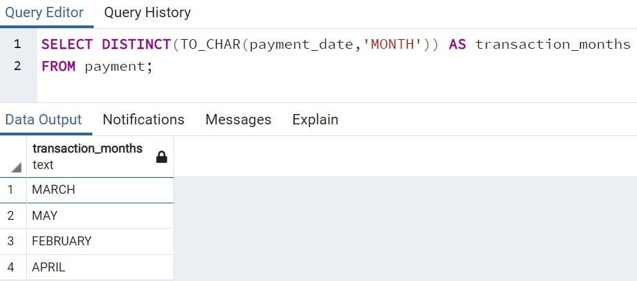

* + How many payments occurred on a Monday?

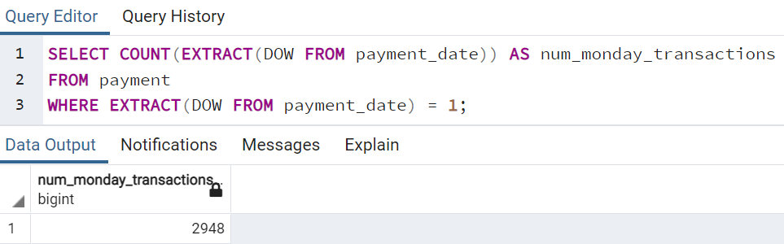

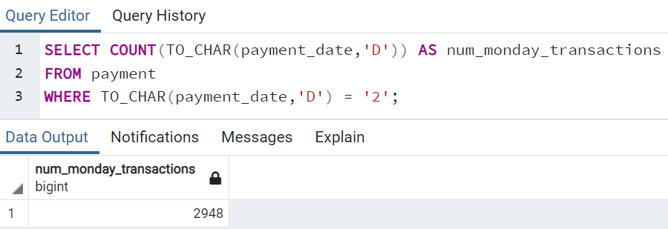

* **Some examples for common business queries (using exercises database):**
  + Retrieve all the information from the cd.facilities table.

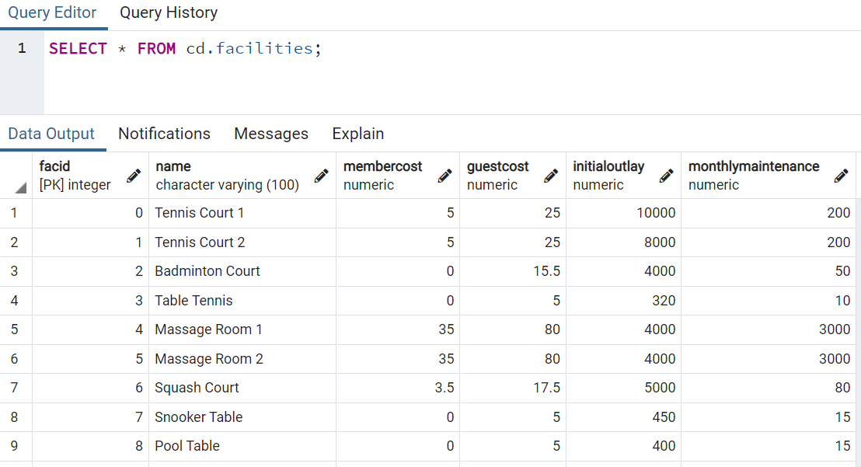

* + Retrieve a list of all of the facilities and their cost to members (Show only facility names and costs).

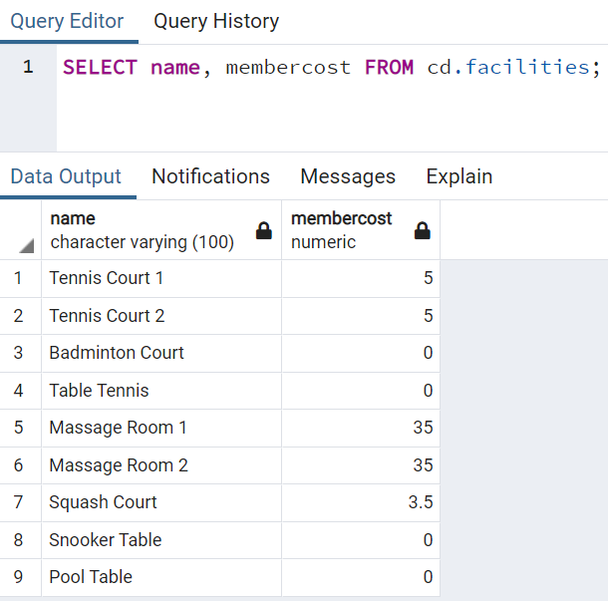

* + Produce a list of facilities that charge a fee to members.

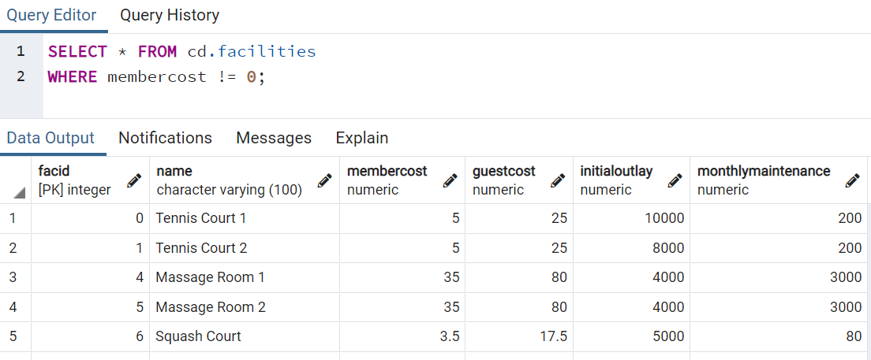

* + Produce a list of facilities that charge a fee to members, and that fee is less than 1/50th of the monthly maintenance cost. Return the facid, facility name, member cost, and monthly maintenance of the facilities in question.

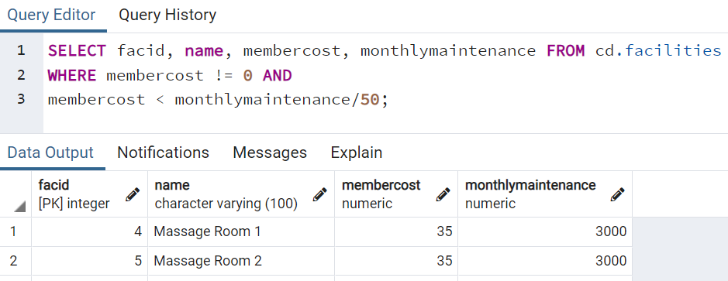

* + Produce a list of all facilities with the word 'Tennis' in their name.

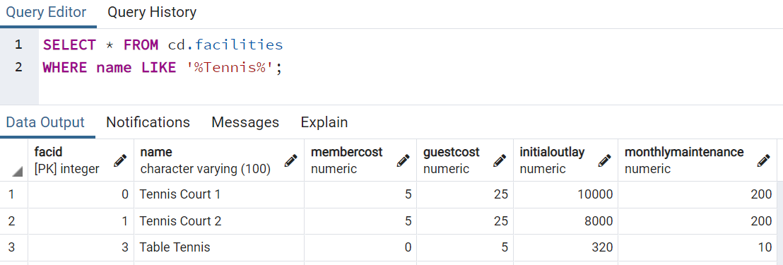

* + Retrieve the details of facilities with ID 1 and 5. Try to do it without using the OR operator.

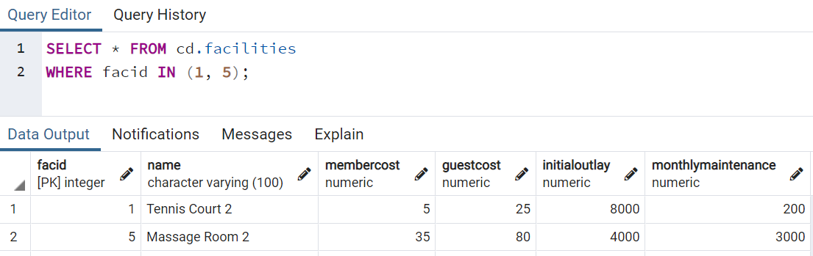

* + Produce a list of members who joined after the start of September 2012. Return the memid, surname, firstname, and joindate of the members in question.

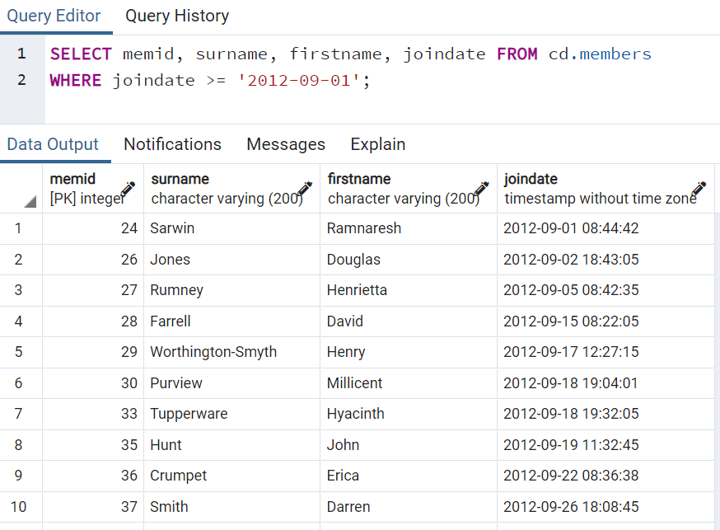

* + Produce an ordered list of the first 10 surnames in the members table. The list must not contain duplicates.

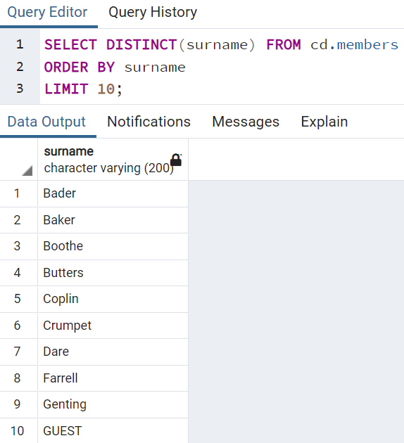

* + Get the signup date of your last member.

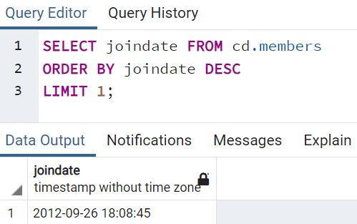

* + Produce a count of the number of facilities that have a cost to guests of 10 or more.

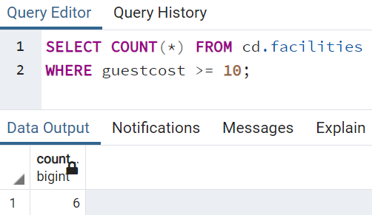

* + Produce a list of the total number of slots booked per facility in the month of September 2012. Produce an output table consisting of facility id and slots, sorted by the number of slots.

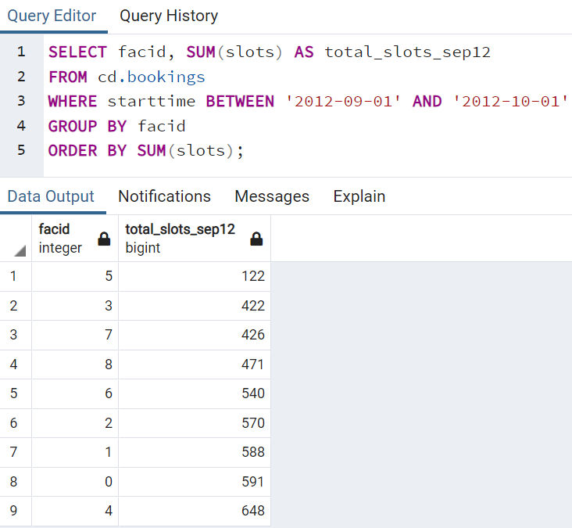

* + Produce a list of facilities with more than 1000 slots booked. Produce an output table consisting of facility id and total slots, sorted by facility id.

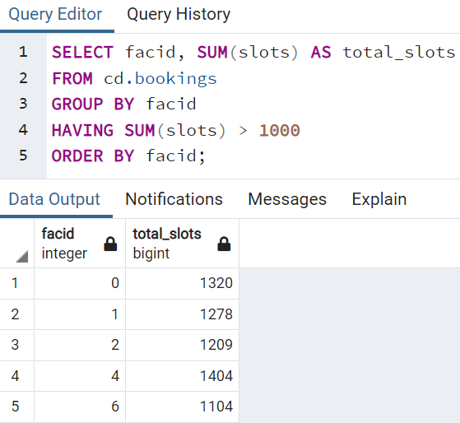

* + Produce a list of the start times for bookings for tennis courts, for the date '2012-09-21'. Return a list of start time and facility name pairings, ordered by the time.

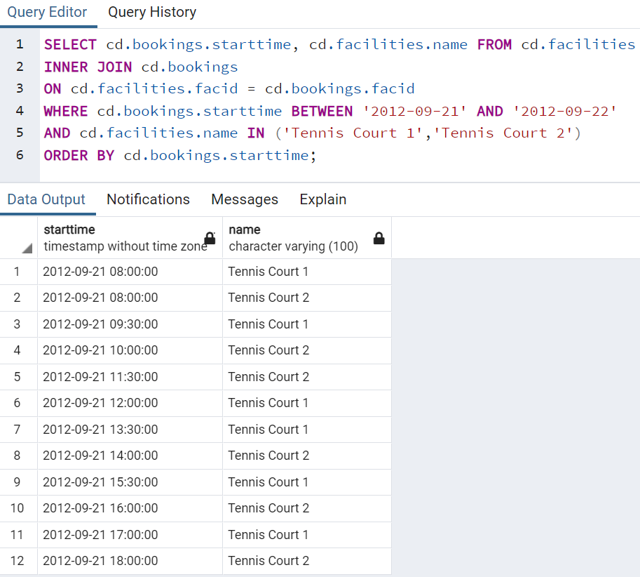

* + Produce a list of the start times for bookings by members named 'David Farrell'.

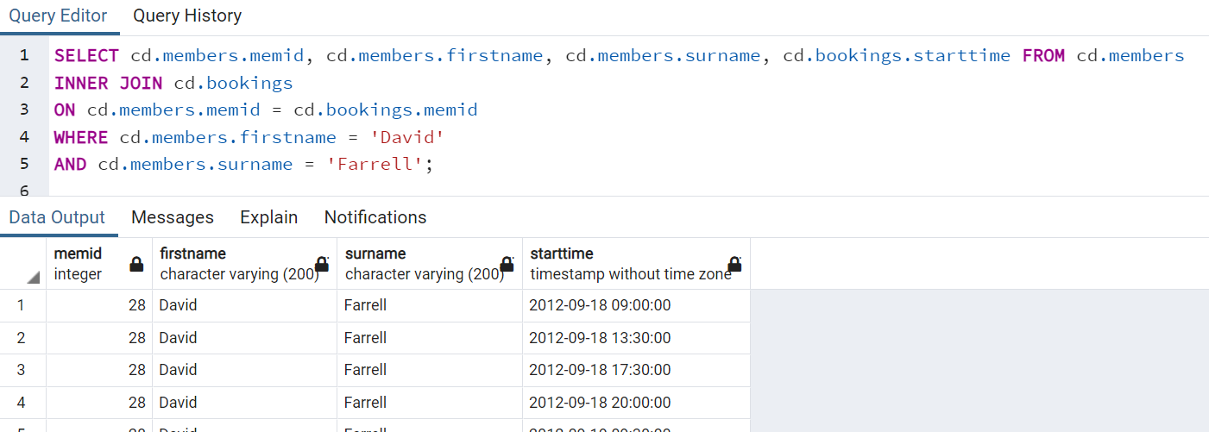

**Creating Databases and Tables:**

* **Definitions:**
  + **Data types**
    - Data type is a classification that specifies which type of value a variable has and what type of mathematical, relational or logical operations can be applied to it without causing an error.
    - Common data types: Boolean (true or false), character (char, varchar, text), numeric (integer, floating point number), temporal (date, time, timestamp, interval).
    - Not so common data types: UUID (Universally Unique Identifiers), array (stores an array of strings, numbers, etc.), JSON (JavaScript Object Notation), Hstore key-value pair, network addresses and geometric data.
    - Careful consideration is required when choosing what data types to use for storing data.
    - Search online for best practice.
    - For example, for phone number it is better to use text-based data type rather than numeric-based data type since no mathematical operation is expected for phone number. Another reason is, for example, both 07 and 7 are considered same for some numerical data type (eg. integer). However, ‘07’ and ‘7’ are considered different for string data type for phone number.
    - Plan for long term storage when creating database and table.
    - We can always remove historical information, but we cannot go back in time to add in information.
  + **Primary key**
    - A primary key is a column, or a group of columns used to identify a row uniquely in a table (eg. in the dvdrental database, customers have unique, non-null customer_id column as their primary key).
    - Primary keys are also important since they allow us to easily discern what columns should be used for joining tables together.
  + **Foreign key**
    - A foreign key is a field or group of fields in a table that uniquely identifies a row in another table.
    - A foreign key is defined in a table that references to the primary key of the other table.
    - Referencing table (child table): the table that contains the foreign key.
    - Referenced table (parent table): the table to which the foreign key references.
    - A table can have multiple foreign keys depending on its relationships with other tables.

Note: Primary key and foreign keys of a table can be checked under its Constraints within Schemas:

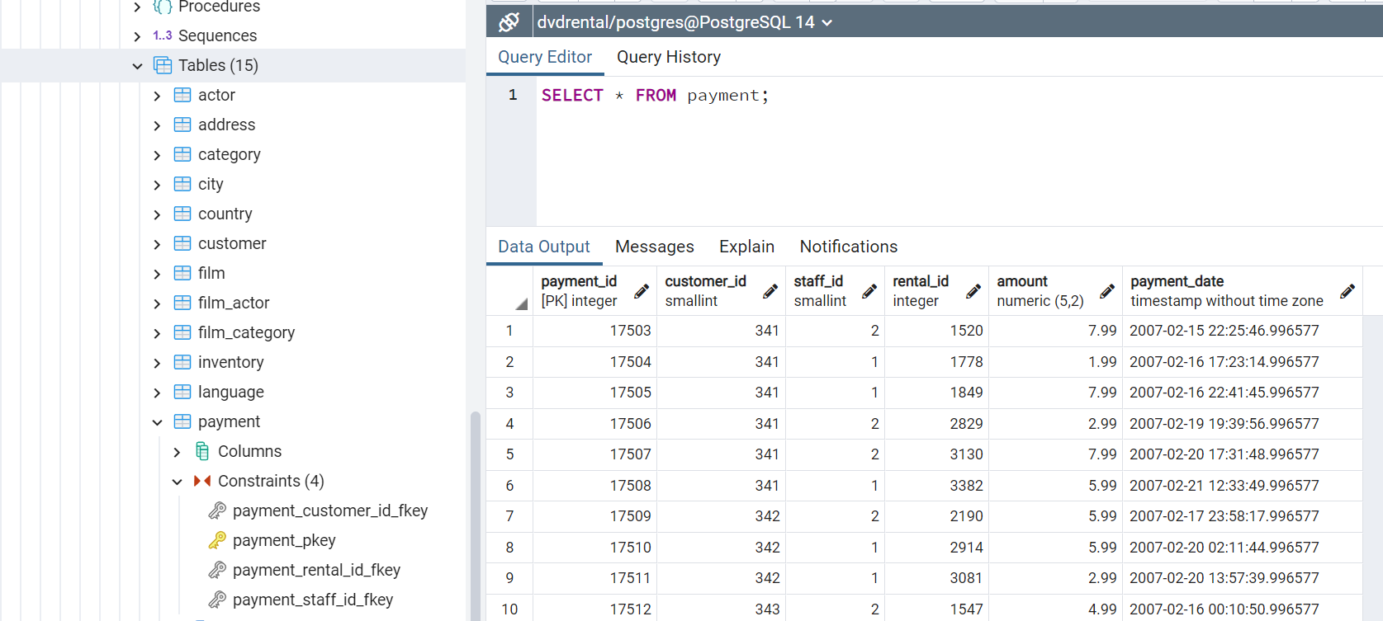

Note: Column payment_id with [PK] integer is the primary key, and the other 3 columns are foreign keys for the payment table.

* + **Constraints**
    - Constraints are the rules enforced on data columns on table, which are used to prevent invalid data from being entered into the database.
    - This ensures the accuracy and reliability of the data in the database.
    - Constraints can be divided into two main categories:
      * Column constraints:

Constrain the data in a column to adhere to certain conditions.

* + - * Table constraints:

Applied to entire table rather than to an individual column.

* + - The most commonly used column constraints:
      * NOT NULL:

Ensures that a column cannot have NULL value.

* + - * UNIQUE:

Ensures that all values in a column are different.

* + - * PRIMARY KEY:

Uniquely identifies each row/record in a database table.

* + - * FOREIGN KEY:

Constrains data based on columns in other tables.

* + - * CHECK:

Ensures that all values in a column satisfy certain conditions.

* + - * EXCLUSION:

Ensures that if any two rows are compared on the specified column or expression using the specified operator, not all of these comparisons will return TRUE.

* + - The most commonly used table constraints:
      * CHECK (condition):

To check a condition when inserting or updating data.

* + - * REFERENCES:

To constrain the value stored in the column that must exist in a column in another table.

* + - * UNIQUE (column_list):

Forces the values stored in the columns listed inside the parentheses to be unique.

* + - * PRIMARY KEY (column_list):

Allows us to define the primary key that consists of multiple columns.

* **Creating tables using CREATE TABLE:**
  + Full general syntax:

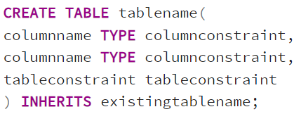

* + Common simple syntax:

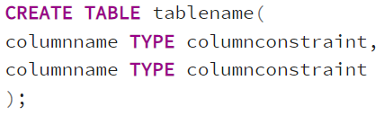

Example syntax:

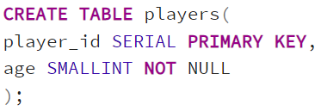

* + When creating new table, the first column is normally the primary key column, and SERIAL shall be specified for the column type:
    - In PostgreSQL, a sequence is a special kind of database object that generates a sequence of integers.
    - A sequence is often used as the primary key column in a table.
    - SERIAL will create a sequence object and set the next value generated by the sequence as the default value for the column.
    - This is perfect for a primary key, because it logs unique integer entries automatically upon insertion.
    - If a row is later removed, the column with the SERIAL data type will not adjust, marking the fact that a row was removed from the sequence.
  + Example for creating tables:

Create a new table “account”:

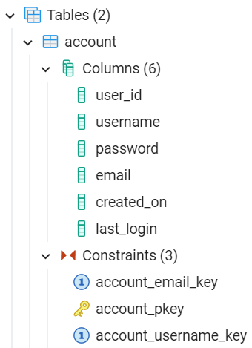 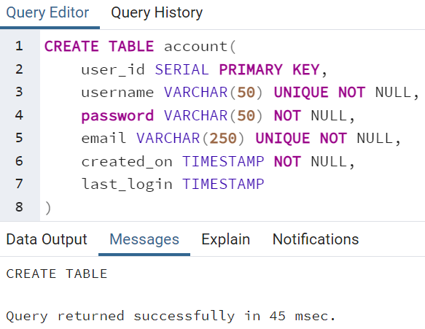

Create a new table “job”:

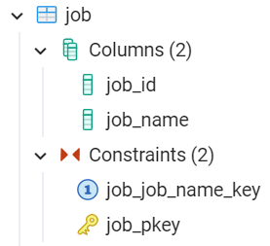 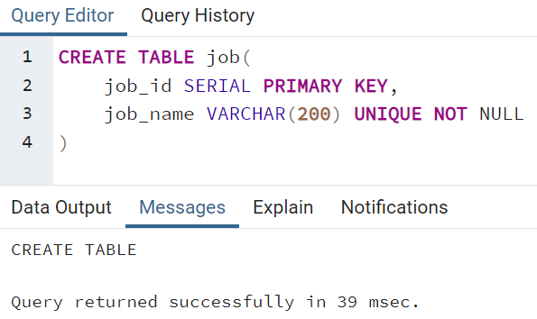

Create a new table “account_job” which references the primary keys from “account” and “job” tables:

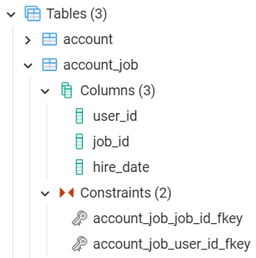 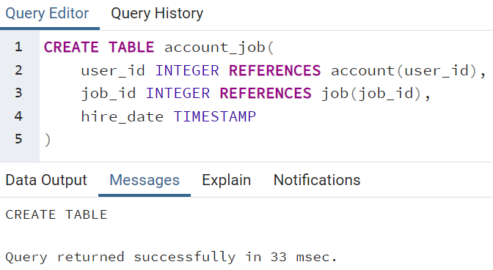

* **Inserting information into tables using INSERT:**
  + INSERT allows us to add in rows to a table.
  + General syntax:

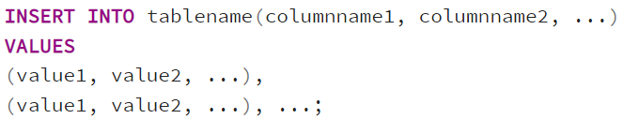

* + Syntax for inserting values from another table:

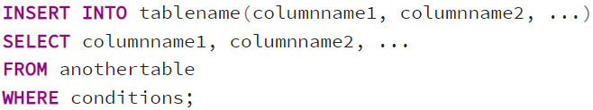

Note: The inserted row values must match up for the table, including constraints. SERIAL columns do not need to be provided a value.

* + Example for inserting information into tables:

Inserting information into “account” table:

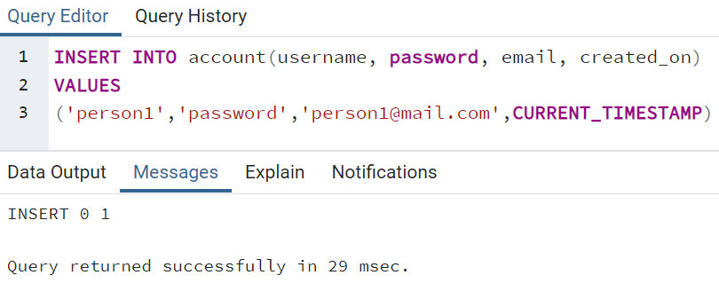

Note: There is no need to specify used_id (primary key) as it is of SERIAL data type, and it will be generated automatically.

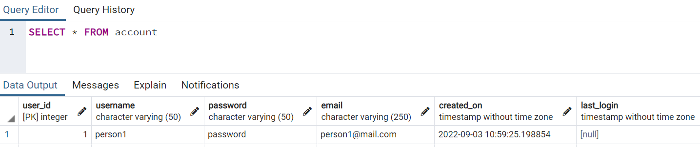

Inserting information into “job” table:

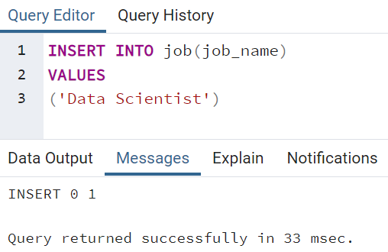

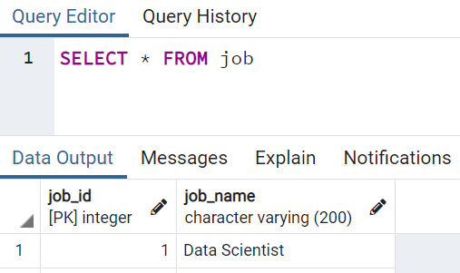

Add in another job name into “job” table:

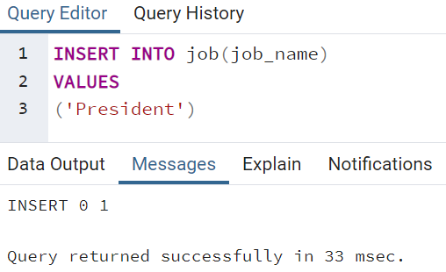

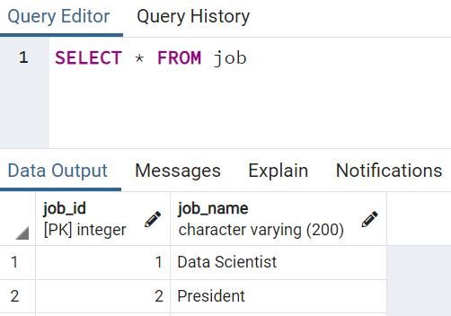

Note: The job_id (primary key) of SERIAL data type is generated automatically.

Inserting information into “account_job” table:

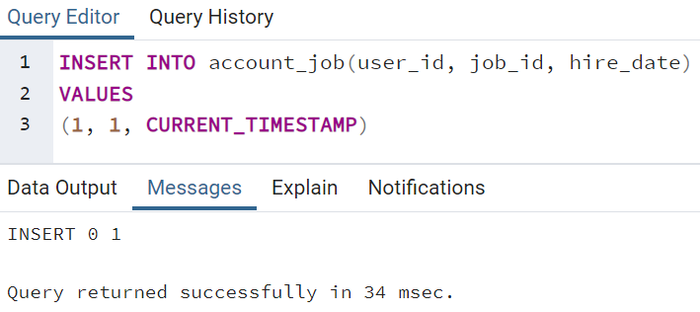

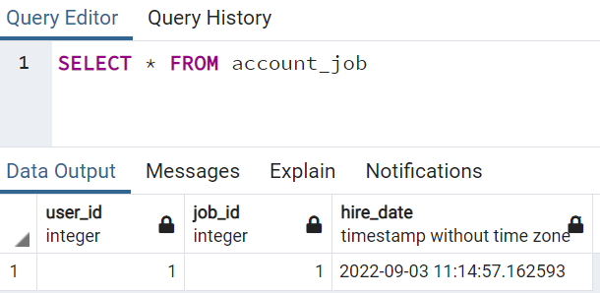

Note: If we attempt to add in user_id and/or job_id which does not exist, an error will occur since we already set the foreign key constraints for these columns when creating the table:

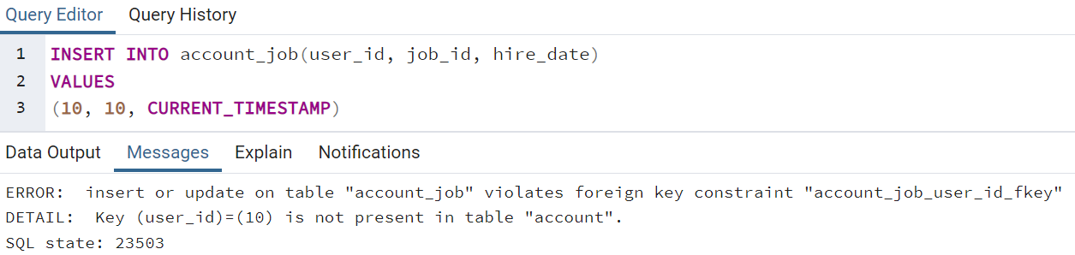

* **Updating table information using UPDATE:**
  + UPDATE allows us to change values of columns in a table.
  + General syntax:

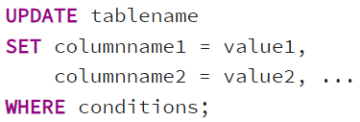

* + Update based on another column:

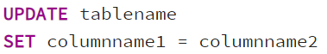

* + Update using another table’s values (UPDATE join):

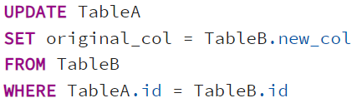

* + Example for updating tables:

Update the “last_login” column of “account” table which is originally null:

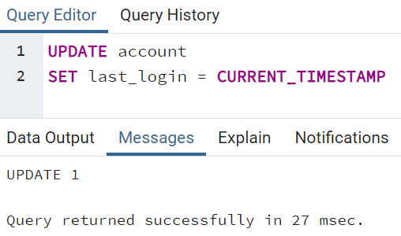

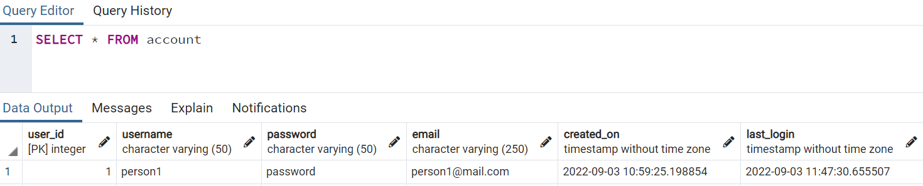

Update the “last_login” column of “account” table to match "created_on” column:

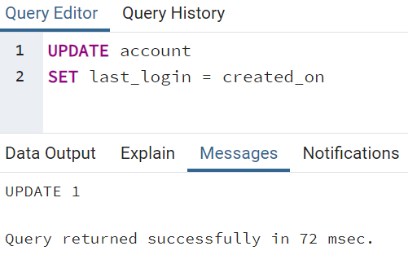

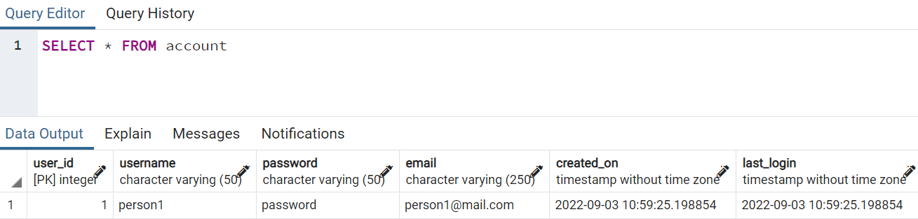

* + Update based on two tables:

To update “hire_date” of “account_job” to match the “created_on” of “account”:

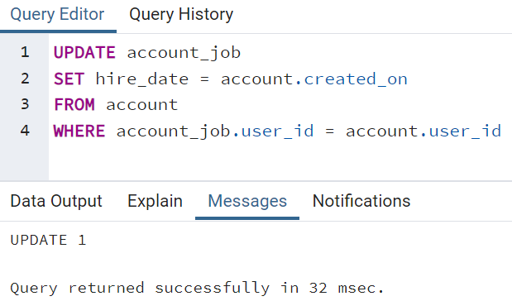

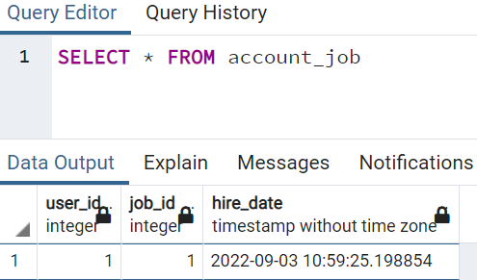

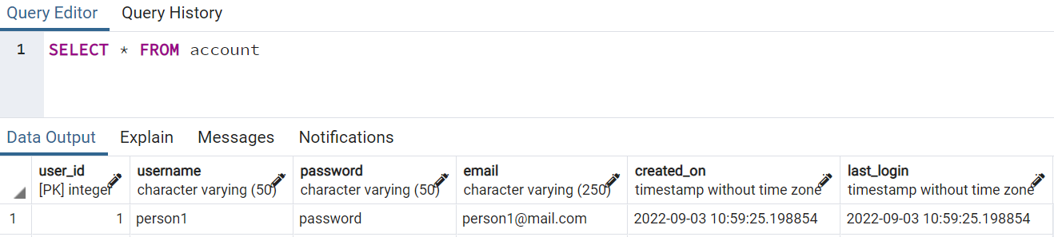

* **Removing rows from table using DELETE:**
  + General syntax:

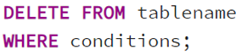

* + Delete rows based on their presence in other tables:

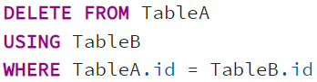

* + Delete all rows from a table:



* + Example for deleting row from table:

Delete the row with job_name = “President” from the “job” table:

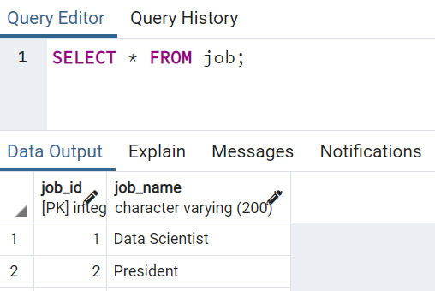

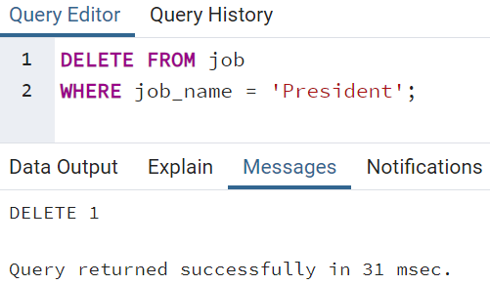

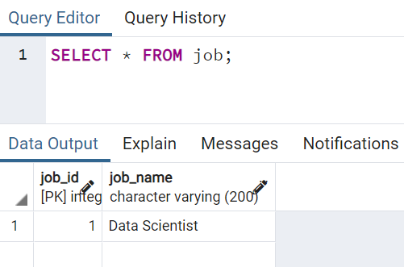

Note: The row with job_name = “President” has been deleted from the table.

* **Changing existing table structure using ALTER:**
  + ALTER allows us to change existing table structure, such as:
    - Adding, dropping, or renaming columns
    - Changing a column’s data type
    - Set DEFAULT values for a column
    - Add CHECK constraints
    - Rename table
  + General syntax:



For adding columns:

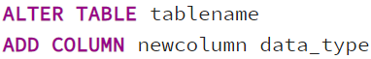

For removing columns:

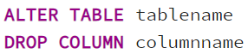

For altering constraints:

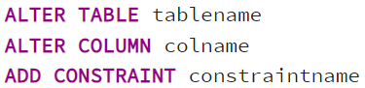

* + Example for using ALTER TABLE:

First create a new table “information”:

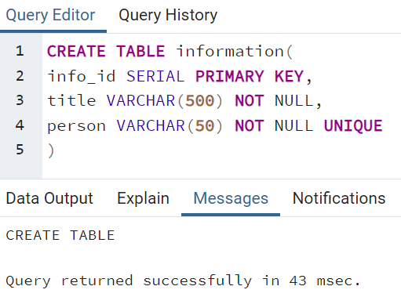

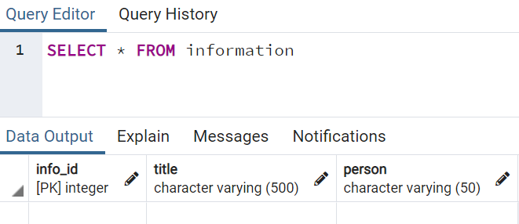

Rename the table name “information” to “new_info”:

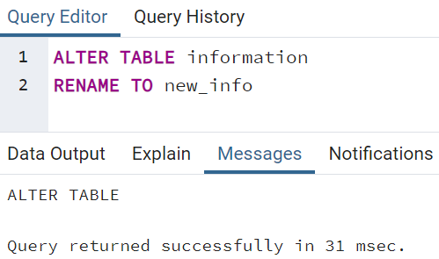

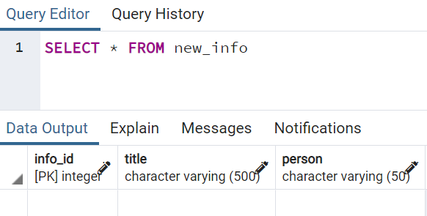

Rename column “person” from table “new_info” to “people”:

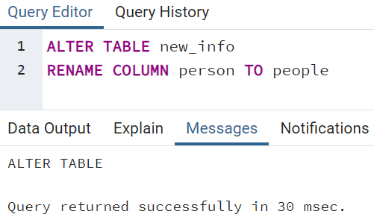

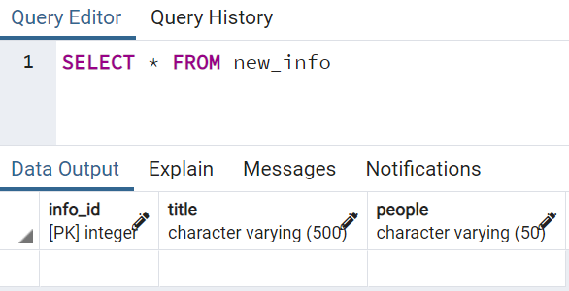

Drop the NOT NULL constraint from “people” column:

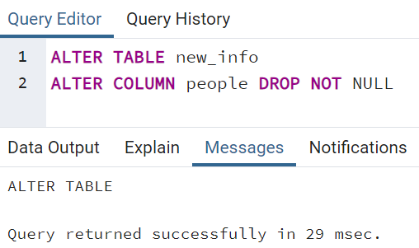

Insert “some new title” into the “title” column of “new_info” table:

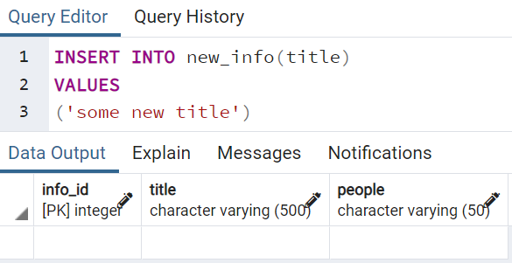

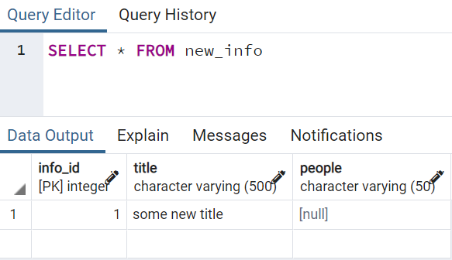

Note: The above null value for “people” column is only allowed if the NOT NULL constraint is dropped from the “people” column using ALTER TABLE. If the NOT NULL constraint is not dropped from the “people” column, an error will show up since we only insert value into the “title” column.

* **Removing column from table using DROP:**
  + DROP allows us to remove a column from a table completely.
  + In PostgreSQL this will also automatically remove all of its indexes and constraints involving the column.
  + However, it will not remove columns used in views, triggers, or stored procedures without the additional CASCADE clause.
  + General syntax:

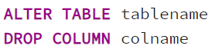

Use CASCADE if to remove all dependencies of the column:

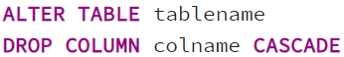

Check for existence to avoid error using IF EXISTS:

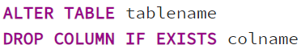

For dropping multiple columns:

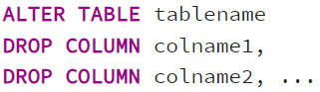

* + Example for using DROP:

Drop the “people” column from the “new_info” table:



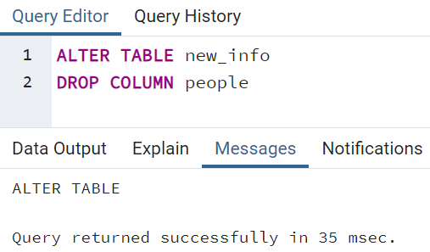

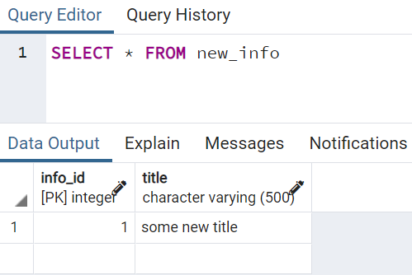

Note: The “people” column has been dropped from the table.

* **Creating customized constraints using CHECK:**
  + CHECK allows us to create more customized constraints that adhere to a certain condition (such as making sure all inserted integer values fall below a certain threshold).
  + Example syntax:

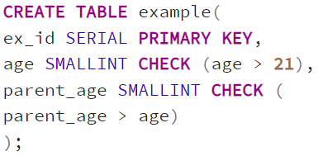

Note: The about codes use CHECK to ensure input age is over 21 and parent age must be greater than age.

* + Example for using CHECK:

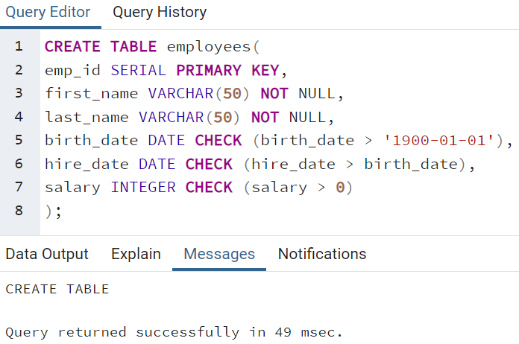

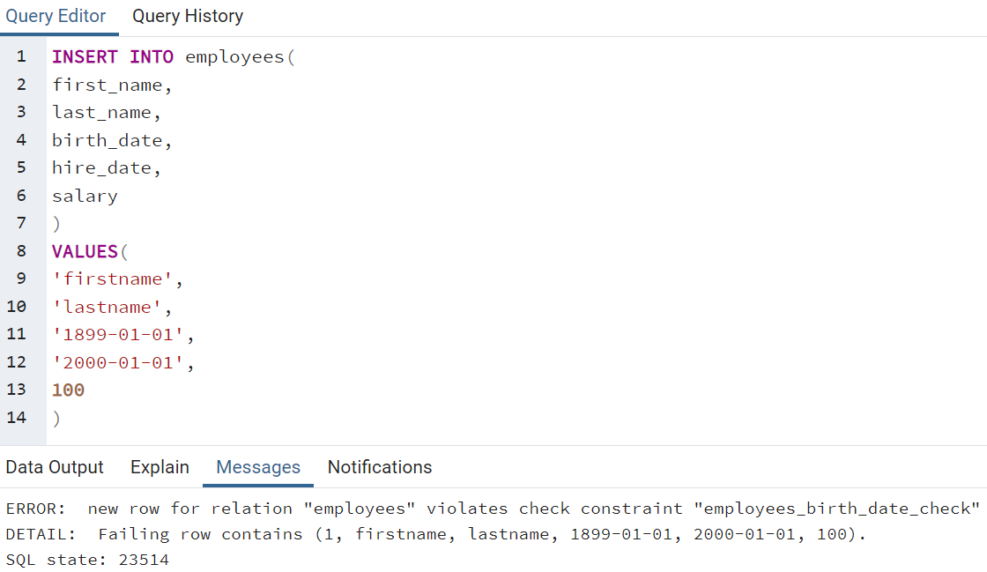

Note: An error is shown as the entered birth date is before ‘1900-01-01’, which is not allowed.

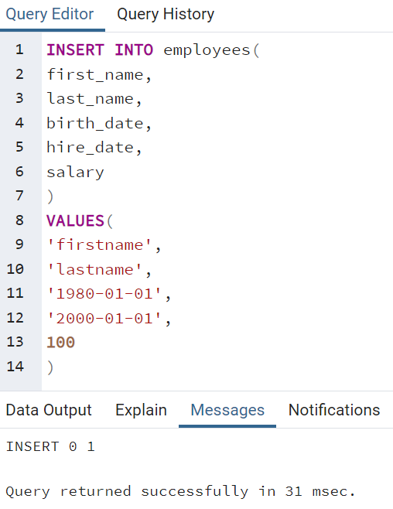

Note: The birth date has been changed to some date after ‘1900-01-01’ and before the hire date ‘2000-01-01’, and the row has been successfully input into the “employees” table.

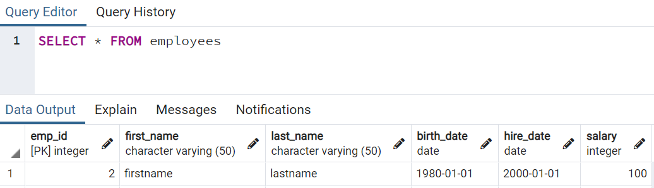

**Conditional Expressions and Operators:**

* CASE
  + We can use the CASE statement to only execute SQL code when certain conditions are met.
  + This is very similar to IF/ELSE statements in other programming languages.
  + Two ways to use a CASE statement, either a general CASE or a CASE expression.
  + General CASE is more flexible compared to CASE expression.
  + General CASE syntax:

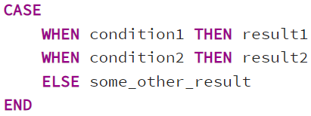

Example:

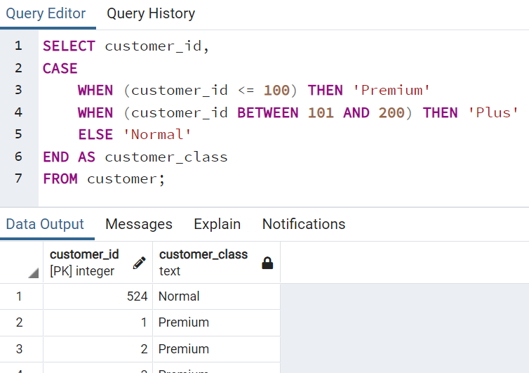

* + CASE expression syntax:

CASE expression syntax first evaluates an expression then compares the result with each value in the WHEN clauses sequentially. Simpler version and good for checking “equality”.

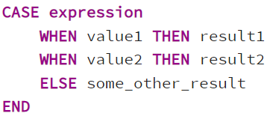

Example:

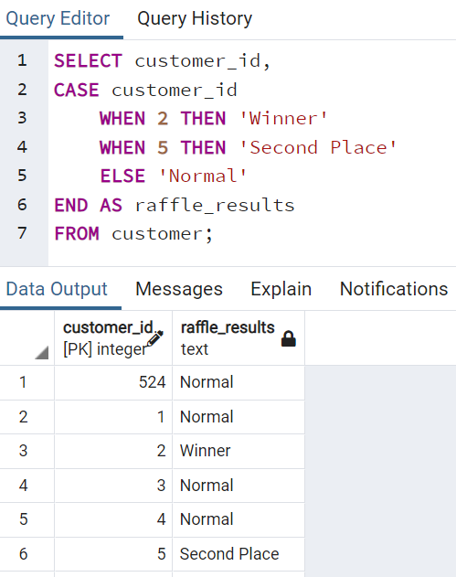

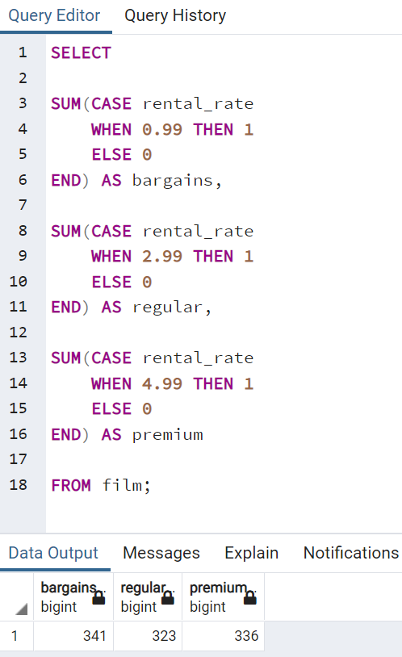

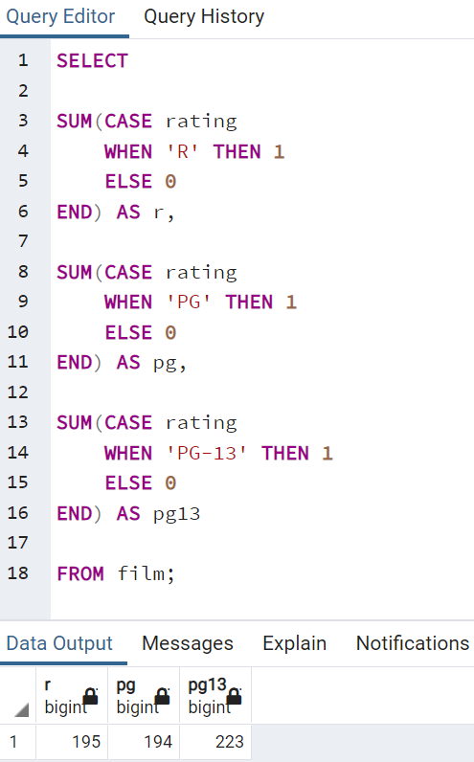

* COALESCE
  + Function that accepts an unlimited number of arguments. It returns the first argument that is not null. If all arguments are null, the COALESCE function will return null.
  + COALESCE function becomes useful when querying a table that contains null values and substituting it with another value.
  + Syntax: COALESCE(arg_1, arg_2, …, arg_n)
  + Examples:

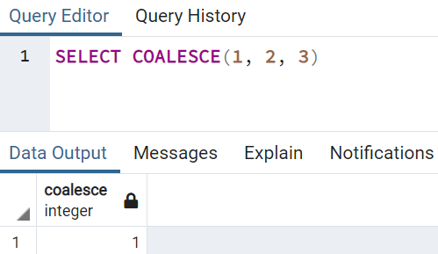

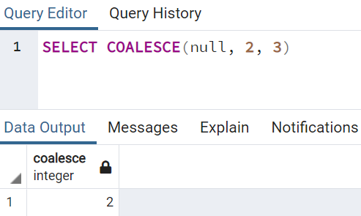

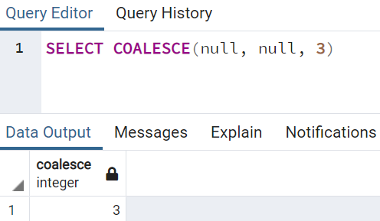

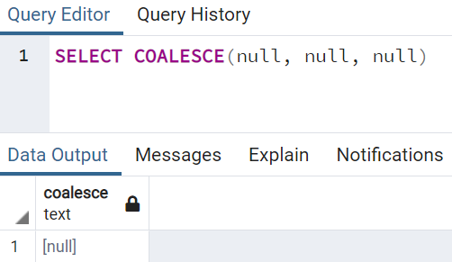

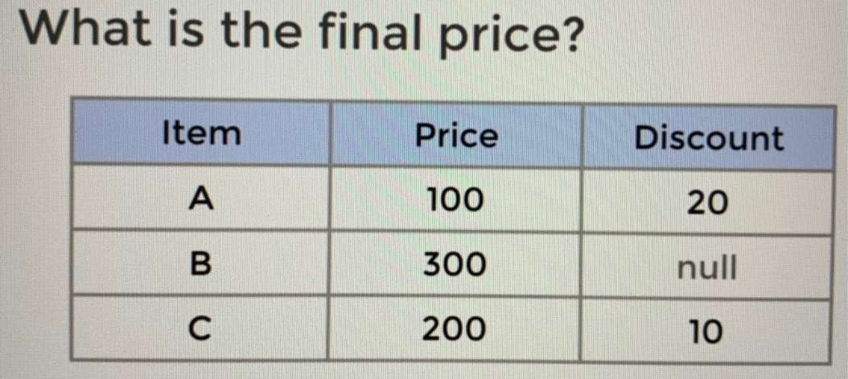

Note: The table above contains null value in the Discount column, and it will cause null issue when performing mathematical operations on it.

If directly calculating the final price by normal subtraction, null will be shown for the final price of item B since its discount value is null:

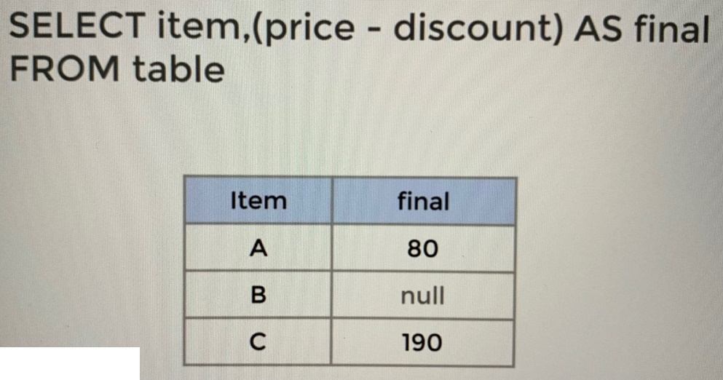

To solve the null issue, COALESCE() can be used:

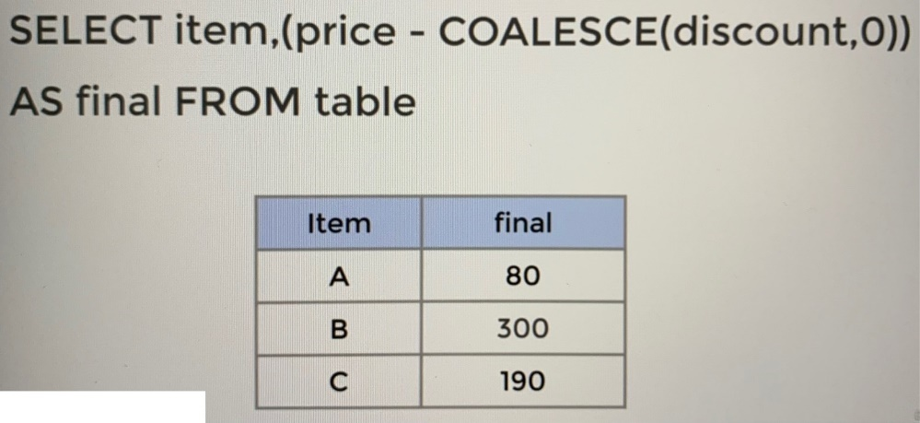

Note: In the code above, COALESCE() first checks its first argument. In this case, since the discount for item B is null, it will return its next argument, value of 0, which is not null. Hence the results of the subtraction can be shown correctly (no null value will be shown for the final price of item B).

* CAST
  + Convert from one data type into another.
  + Not all conversions are possible. Data types for conversion must be reasonable (eg. ‘5’ to integer will work, but ‘five’ to integer will not).
  + Example:

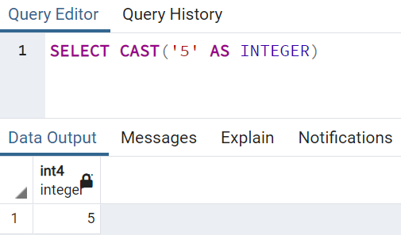

One example use case of CAST() is to return the length (how many digits) of the inventory_id. It is required to convert inventory_id into character format first, and then use CHAR_LENGTH() to return the length of the character. If the conversion is not done before calling CHAR_LENGTH(), an error will occur.

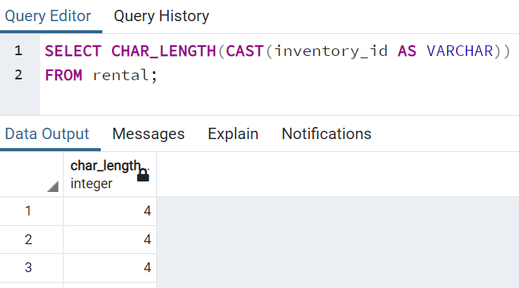

* NULLIF
  + Take in 2 inputs and return NULL if both are equal, otherwise it returns the first argument passed.
  + This becomes very useful in cases where a NULL value would cause an error or unwanted result.
  + Syntax:

NULLIF(arg1, arg2)

* + Example:

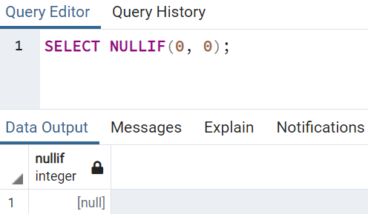

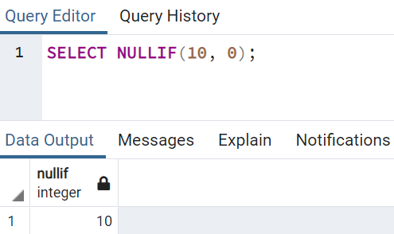

Calculate the ratio of number of employees from department A to department B. Currently there is no employee in department B and error will show up if NULLIF() is not used since we cannot divide any number with 0. For using NULLIF() in this example, we input 0 as the second argument, and it will be used to check against with the value of the first argument. If the first argument is 0 (no employee in department B), NULL will be used for the denominator and the resultant ratio will be null instead of an error.

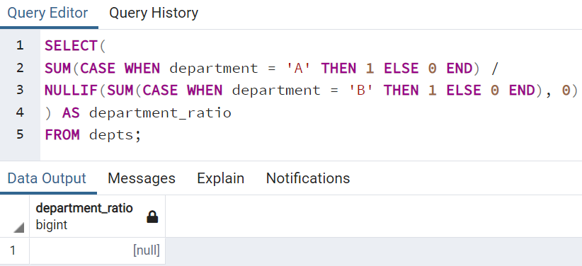

* Views
  + Often there are specific combinations of tables and conditions that we find ourselves using quite often for a project.
  + Instead of having to perform the same query repeatedly as a starting point, we can create a VIEW to quickly see this query with a simple call. For example, if joining of two tables is always required before performing other queries, the query for joining the two tables can be stored as a view and the query can be called by just using syntax: SELECT * FROM view.
  + A view is a database object that is of a stored query.
  + Notice that a view does not store data physically, it simply stores the query.
  + A view can be accessed as a virtual table in PostgreSQL.
  + Existing views can be updated and altered.
  + Example:

Create a View for storing a query for joining customer and address tables on address_id:

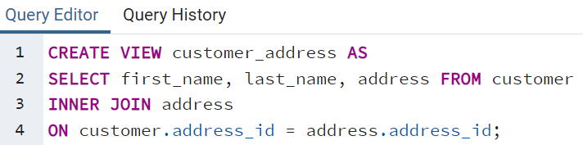

Calling the query for joining using the stored view customer_address:

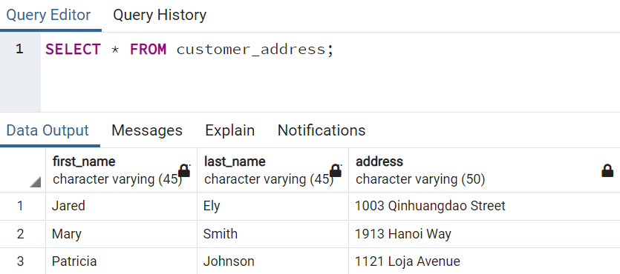

Note: Creating view for storing query is very useful since the queries can become complex very easily.

Update the existing view customer_address by adding in the district column using CREATE OR REPLACE VIEW:

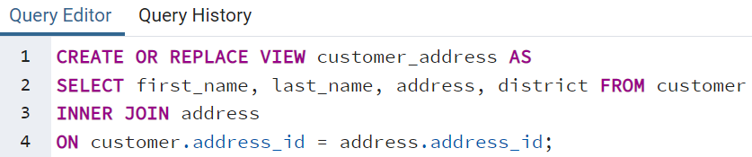

Calling the updated query using the stored view customer_address:

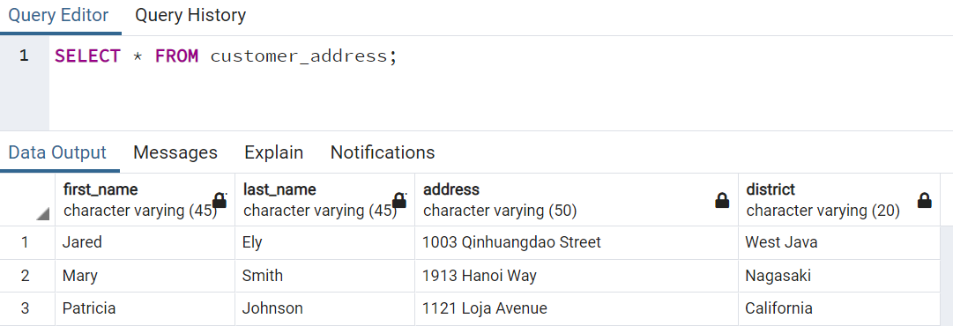

For dropping an existing view:

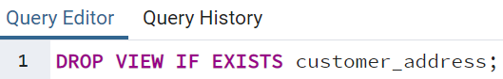

Note: Use IF EXISTS to prevent error.

For renaming an existing view:



**PostgreSQL with Python:**

* In this section, the basics of connecting to a PostgreSQL database using Python's psycopg2 package in Jupyter Notebook will be shown.

